Excessive surfing
What can I do to become totally addicted? How can I support others to do so?
At first you have to buy a smartphone, that’s the most important step on your way to becoming addicted. You also need an internet access, of course.It’s also important to get rid of your friends, they might disturb you so you have to leave them. Don’t care about school, sleep or other duties. Just stay online also during the nights. When you want someone to become addicted, support them by buying the latest smartphone and be sure that the person has internet access all the time.

Who may I never ever talk to about my problems?
This is my problem. I can’t tell anyone, because nobody cares. I must deal with this thing by myself. I may never ever talk about my problems to family: parents, siblings and so on. Friends, teachers school nurse, psychologist also shouldn’t know. I can’t use help lines.

Which websites should you by no means visit?
You should not visit any pages which will tell you what to do, such as online helplines like saferinternet.at, teenlineonline.org, and so on. On these sites, someone might try to change you into what they want you to be.

FACTS
While time spent online can be hugely productive, compulsive Internet use can interfere with daily life, work, and relationships. When you feel more comfortable with your online friends than your real ones, or if you can’t stop yourself from playing games, gambling, or compulsively checking your smartphone, tablet, or other mobile device—even when it has negative consequences in your life—then you may be using the Internet too much.
What is excessive surfing?
Excessive surfing means using the internet so much that it will have consequences on important things such as schoolwork/work, ergonomics, social life, and other things. Some scientists do not think that the use of internet represents an addiction. Others think it is not enough statistics that say what is normal and what is not.
The first signs of addiction
Many people turn to the Internet in order to manage unpleasant feelings like stress, loneliness, depression, and anxiety. When you have a bad day and you are looking for a way to escape your problems or to quickly relieve stress, the Internet can be a very good distraction. Losing yourself online can temporarily make feelings such as loneliness, stress, anxiety, depression, and boredom blow away.
Signs and symptoms of Internet addiction vary from person to person. For example, there are no set hours per day or number of messages sent that indicate Internet addiction. But here are some general warning signs that your Internet use may have become a problem:
- Isolation from family and friends
- No time for finishing schoolwork or other work
- Getting defensive about your internet use
- Losing track of time online
- Getting shaky and annoyed when you aren’t onlin

Statistics:
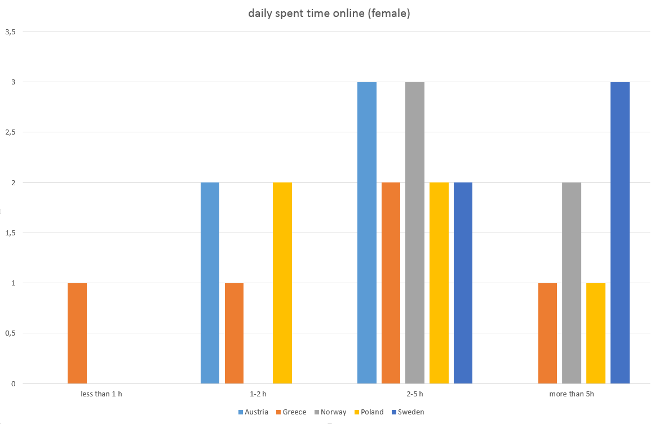

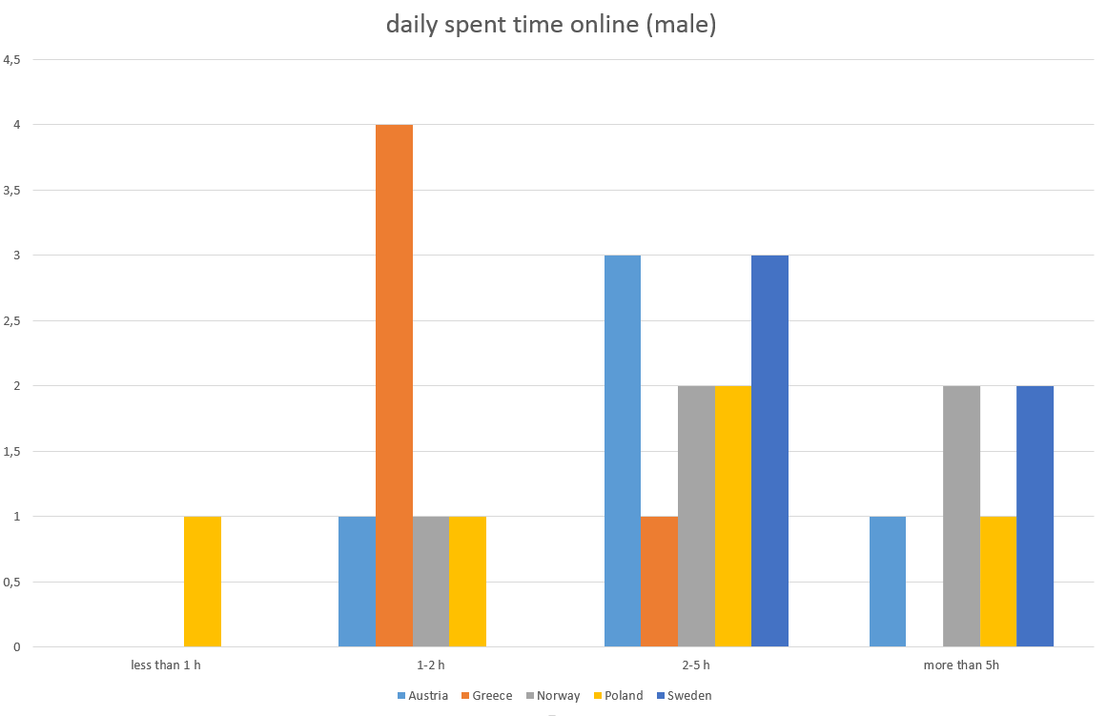
When can you be considered a real online junkie?
You can be considered a real online junkie when you feel that you are losing sleep because of your internet addiction. You are starting to lose all your friends and social life as well and become really unsocial and you don’t even react when things happen around you.
Another thing is, if your internet addiction affects your homework or schoolwork and your grades are starting to get worse and maybe you fail a lot of tests. You feel that your health is becoming really bad and your back hurts because of bad ergonomics when you sit at the computer or your smartphone all day long. Another common thing when you are a real online junkie is that you easily get annoyed and you have mood changes, sometimes you get shaky just because you haven’t been connected to internet or checked your social media for a while. If you recognise yourself in the signs/things mentioned above you can consider yourself a real online junkie

