Each school has held special Sifa Days throughout the whole project. During the days, different events took place, e.g. presentations, workshops, interviews and discussions. To make the days more valuable, specialists in IT were invited to give lectures or run workshops. The Sifa Days were celebrated by the whole school community. However, the way the events were organised, depended on each school separately. The information about such special days was advertised by means of leaflets, brochures and announcements. Later, the information and photos were published on the SIFA site and in the local media.

Austria

A4 Austria | March 2015 | Safe Internet Day : 24 hours challenge - without internet and mobile phone. 150 students taking part voluntarily! | http://www.sifaplus.eu/de/sucht/artikel/item/132-24-hours-without-internet-and-mobile-phone-follow-up

2 June 2016 | SIFA day I: workshop sexting for 2ak | https://www.facebook.com/hak.has.ybbs/posts/514202948772190
6 June 2016 | SIFA day II: workshop sexting for 2as | https://www.facebook.com/hak.has.ybbs/posts/514202948772190
13 June 2016 | SIFA day III: workshop sexting for 2bk | https://www.facebook.com/hak.has.ybbs/posts/514202948772190

Norway

A5 Norway | 05.05.15 | SIFA-day at school  We used the brochures that was produced in Austria, and the students who traveled to Austria lectured and talked about their experience in Austria. | 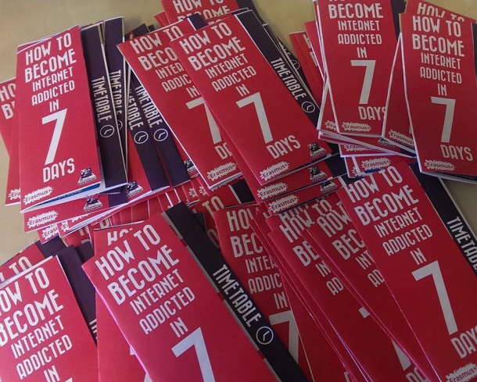

A5 Norway | 05.05.15 | SIFA-day at school. The students showed the films made in Norway about health. | http://www.sifaplus.eu/en/health/results

A5 Norway | 05/05/15 | SIFA-day at school. The students who went to Sweden presented their final product for their fellow students. | http://www.sifaplus.eu/en/security/articles/item/274-dissemenation-activity-os-norway

A3  Norway | 25. January 2016 | The students held a presentation for 50 of the students at the school about their experiences and what they had learned. The students played the Kahoot which was the end result in Greece. | 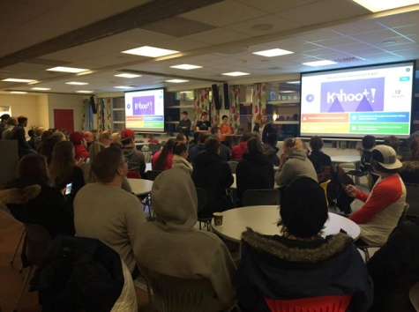

A5 Norway | 18.05.16 | Students worked with some questions regarding the different topics presented by the students who had been in Poland | http://www.sifaplus.eu/en/safety/articles/item/374-sifa-day-in-norway

A5 Norway | 18.05.16 | Students worked with some questions regarding the different topics presented by the students who had been in Poland | http://www.sifaplus.eu/en/safety/articles/item/374-sifa-day-in-norway

Sweden
SIFA DAY
29 Jan  2015 | SIFA Lecture day in Vänersborg  over 300 pupils aged 11-16 from Trollhättan and Vänersborg attended the SIFA day in Vänersborg. The activities were followed by a parental evening with a two hour lecture on” Youth and the Internet”. | http://www.sifaplus.eu/en/addictions/articles/item/126-sifa-lecture-day-in-vaenersborg-29-jan-2015

SAFER INTERNET DAY - with focus on the SIFA project too
2015FEB | 10 Feb | Safer Internet Day (SID) at the Fridagymnasiet upper secondary school. Since the Fridagymnasiet has an outspoken ICT profile, students and teachers save and share most of their work on-line. Addressing safety issues is an ongoing process that goes on all year round and not only on SID. Year one students have been working on a long term project with workshops on the theme: Hidden dangers of the Internet. The focus is on how to use the Internet in a safe way. The students used several occasions of their class hour (which they have three times per week) to work on the material ”Ses offline?” - ”See you offline?”. The final workshops took place on SID - Safer Internet Day, 10 February 2015.
 |  | The Swedish Agency for Youth and Civil Society provides extensive pedagogical material for teachers as well as videos as the basis for discussions and workshops on this topic. | www.mucf.se
 | 10 Feb | Safer Internet Day (SID) at the Fridagymnasiet, part 2  The Swedish Media Council (Statens medieråd in Swedish) has published a pedagogical material to be used in schools during the MILweek -(Media- och InformationsKunnighet) 9-13 February. The work consist of four parts, training, knowledge about the role of Media in our society, How to search for, analyse and critically value information, as well as communicate and create using the internet and media. The students also competed in groups completing Internet skills tasks. | http://www.sifaplus.eu/en/component/k2/item/155-sid-safer-internet-day-activities-at-the-fridagymnasiet-college-in-vaenersborg-sweden-part-2
2016 | 9 Feb  SID | Information to the students who got the task to bring the information home to their parents.  http://nohate.se/foraldrar/  The Swedish Media Council and Bris celebrate Safer Internet Day with a campaign for the children's most important resource: their parents. Information on young people and the internet, online bullying and hate speech, and a guide on how parents can support their children in their digital lives. The parents' kit includes a booklet with five practical tips, a podcast for parents, and a short film. | Safe internet day  - https://www.betterinternetforkids.eu/web/sweden/sid  - http://nohate.se/foraldrar/  - http://nohate.se/wp-content/uploads/2014/04/No-hate-broschyr-krankningar-foraldrar_utskrift.pdf

Greece

A4  Greece | 23/12/14 | Students presented to students of 2nd Lyceum of Kos work done in Austria and other matters relevant to Safe Internet For All, thus declaring the day an unofficial SIFA day | http://www.sifaplus.eu/en/addictions/articles/item/203-sifa-day-in-greece

A8 Greece | 23/12/14 | Students presented to students of 2nd Lyceum of Kos work done in Austria and other matters relevant to Safe Internet For All, thus declaring the day an unofficial SIFA day | http://www.sifaplus.eu/en/addictions/articles/item/203-sifa-day-in-greece

A4 Greece | 11/5/2015 | SIFA day in school presentations | https://drive.google.com/folderview?id=0B6i1EVWz6r7mfmEwTnFaVEFMTzVGU1p0bmt2LXdBc196QVQ3MHVBTGJ5LWFqNDhHYzB4NlU&usp=sharing

A3 Greece | 6 December 2015 | SIFA DAY for parents at school. Parents were invited. Presentations by students and Psychologist Maria Drosou, movies and discussions took place. | https://drive.google.com/folderview?id=0B6i1EVWz6r7mVnhJeDhpSnhZbEU&usp=sharing

A5 Greece | 9 February 2016 | SIFA DAY for at school.  Webinar with other schools from Greece and Aris Louvris  http://vod-new.sch.gr/asset/detail/D1hPUkeNUuX6WZCMJPzpznr4/t1QepmUQNjmUVPmQkEL1f1ka##Top  and at the same time SIFA day at school for all students aged 15-17.  Presenting video Tagged and discussion activities.  A sample of the workshop and discussion:  https://youtu.be/wFyGlF2cC5w | http://www.etwinning.gr/various/webexreg.php?id=96  https://drive.google.com/folderview?id=0B8uze7tpG5WFZzM4X1JGNVdXcTg&usp=sharing  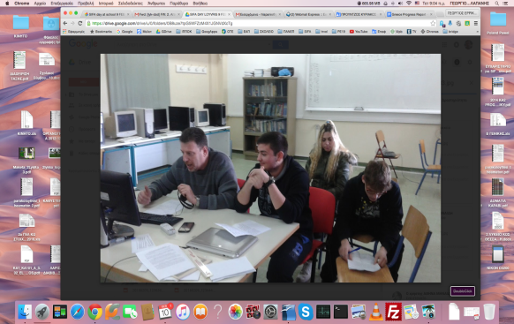  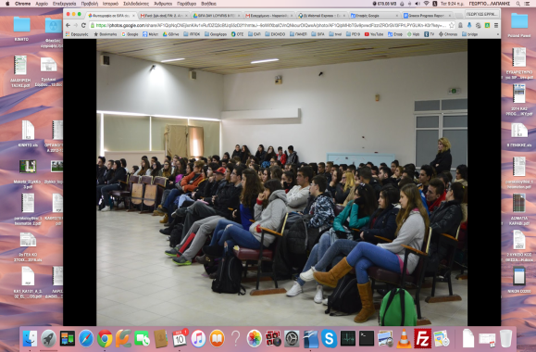  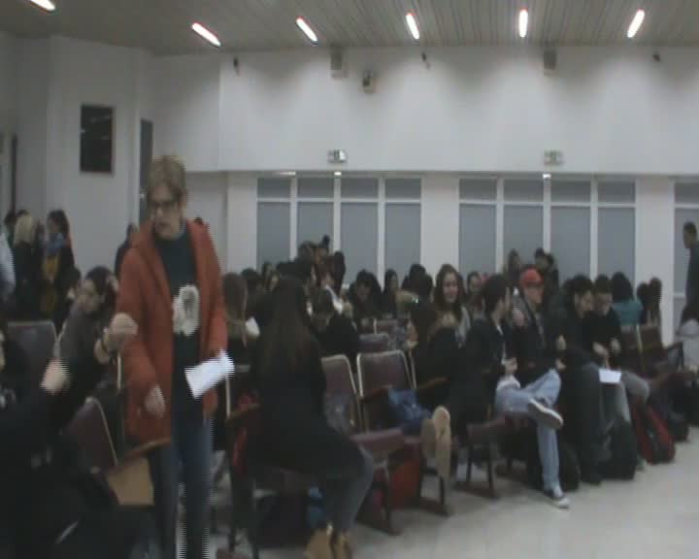

A4 Greece | 9 May 2016 | SIFA Day  Presentations, Games (kahoot), Interviews and filling in of Questionnaires by many students of the school.  2 Kahoot games:  https://play.kahoot.it/#/?quizId=e8245355-039f-4fa4-811e-f759dde4135f  https://play.kahoot.it/#/?quizId=aa1a26fb-00f4-4c4e-9750-44b780239c79 | https://goo.gl/photos/zftZXZVVfAbm19cf6  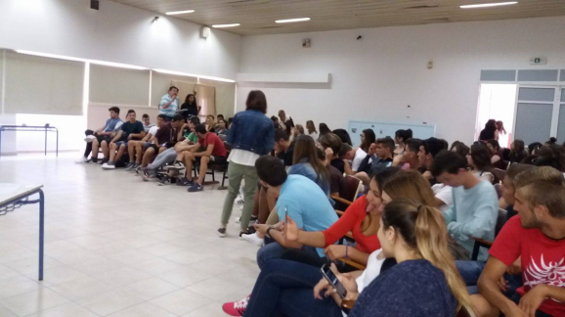

Poland

A3 Poland | 29th Dec 2014 | SIFA DAY - A day without a mobile phone - students were asked not to use their mobile phones for 24 hours and write their comments as a follow-up. | http://www.sifaplus.eu/en/addictions?start=24
A3 Poland | 9th Jan 2015 | 'Virtual violence hurts in real life' - Polish students attend a lecture in LO Grojec given by ALTER organisation on cyberbullying and cyberstalking | http://www.sifaplus.eu/en/addictions/articles/item/65-virtual-violence-hurts-in-real-life-polish-students-attend-a-lecture
A4 Poland | 15th Jan 2015 | Parental meeting - during the meeting in the assembly hall the parents and teachers could watch a presentation on ‘Safe Internet For All’ project in the framework of Erasmus+ project. The audience were informed about all the work that has been done by the project participants, the products of the project and the follow-up steps to be  taken. | http://www.sifaplus.eu/en/addictions/articles/item/119-parental-meeting-l-o-grojec-poland
A3 Poland | 10th feb 2015 | Safe Internet Day: workshops organized by the High School of Information Technology in Warsaw followed by a test. | Certificates.  http://www.sifaplus.eu/en/health?start=12
A3 Poland | 5 Nov 2015 | Presentation on Ethics and visit in Greece – students who participated in the visit answered other students’ questions while presenting information to classes at LO | http://www.sifaplus.eu/en/ethics/articles/item/347-ethics-day-in-grojec
A3 Poland | October 2015 | Organizing an IT course for students on copyrights and safety on the Internet | Students’ certificates.
A4 Poland | 5 Nov 2015 | SIFA Day at school – articles about the event appear on the school webite and in the local media | http://www.sifaplus.eu/en/ethics/articles/item/347-ethics-day-in-grojec
A4  Poland | Nov 2015 - Jan 2016 | The presentations students of L.O. im. P.Skargi in Grojec have given to their peer students since November 2015. The aim of the presentations was to educate young people about the use of the Internet as well as disseminate the results to a wider community. | http://www.sifaplus.eu/en/ethics/articles/item/348-dissemination-presentations-given-by-polish-students
A4 | 26th Jan 2016 | Students in L.O. Grojec held Ethics Day on 5th November 2015. The day started with the presentation of results by the students who participated in the exchange visit in Greece in late September 2015. They shared their experiences and knowledge with their peers from school | http://www.sifaplus.eu/en/ethics/articles/item/347-ethics-day-in-grojec
Licence Άδεια
Our SIFA project has officially ended. Yet, we relevant follow up activities will continue for at least two more years and especially dissemination activities for the results and products that have been created. We would like to thank all students, teachers, parents, organisations and scientists/guests that participated in some way and helped us during the project implementation.
The project is now under evaluation by the Greek National Agency and the products presented might be submitted to some change. Yet, meanwhile, we would like to present the Final Products of this 2 year collaboration, for which we are proud of and have been produced by all participants in SIFA. If they are submitted to changes, the current version will be updated by the revised versions.
Anybody can use the material produced during SIFA implementation, as long as they mention the Erasmus+ Project SIFA and that the products have been created by EU Erasmus+ funding.

The attachments (SIFA products) are licensed under a Creative Commons Attribution 4.0 International License and have been created during the implementation of the Erasmus+ Safe Internet For All (2014‐1‐EL01‐KA201‐001294) project.
Τα προϊόντα που ακολουθούν έχουν άδεια Creative Commons Αναφορά Δημιουργού - Παρόμοια Διανομή 4.0 Διεθνές και έχουν δημιουργηθεί στο πλαίσιο του προγράμματος Erasmus+ Safe Internet For All (Ασφαλές Διαδίκτυο για όλους - Σύμπραξη αποκλειστικά μεταξύ σχολείων με κωδικό 2014‐1‐EL01‐KA201‐001294)

