During the meeting the following matters connected with safety on the Internet were dealt with: cyberbullying, cyberstalking, sexting, grooming, offensive content, online predation, violence on the Internet, pro-ana movement. The participants took part in lectures and workshops run by specialists in the fields. The products of the meeting were the websites (weebly.com) on each of the above topics:

SEXTING: http://sextingsifa.weebly.com
CYBERBULLYING AND CYBERSTALKING: http://sifacyberbullying.weebly.com
GROOMING: http://groomingandpredators.weebly.com/
OFFENSIVE CONTENT: http://offensivecontent.weebly.com

C9 C10  Poland | Sunday 24 April 2016 - Saturday 30 April 2016 | Fifth pupil exchange in Poland:  Matters concerning Safety on the Internet.  Activities such as:  - Presentations of students and teachers participating in the meeting  - Statistics concerning the matters of the meeting presented by partners  - Discussion comparing the phenomena in the countries of the project  - Discussion concerning policies that could help reduce the problems encountered  - Searching for solutions to reduce the problems (workshop)  - Making decisions about activities following-up the meeting (workshop to prepare material)  - Making decisions about results of the meetings and material posted on the SIFA site  - Activities in order to know the culture of the country where the meeting is held  - Assessment of meeting (questionnaires)  Participants:  Teachers:  Poland: Pawel Posnik,Ada Posnik, Anna Mocarska-Karwan,Iwona Kwapisz, Malgorzata Czacharowska, Tomasz Krawczak, Zbigniew Krawczak.  Austria: Michael Pölzl, Brigitte Lindenhofer  Greece: GEORGIOS ERRIKOS CHLAPANIS, ATHINA MINAIDI, MARIA LOUMANI  Norway: Tone Hadler-Olsen, Mona Stigen, Elisabeth Irgens Casèn Pihl  Sweden: Robert Tuveson, Erik Alvin  Students:  Poland: Aneta Ernest, Ewelina Łomża, Igor Mazurek, Maciej Szewczyk, Pawel Górecki, Agnieszka Mazur, Julia Maciejewska, Szymon Bukowski, Julia Świdzińska, Inga Katana, Kacper Lasota, Jakub Kępka, Zuzanna Lewandowska, Magdalena Duch, Karolina Ejmocka, Zuzanna Durka  Austria: LENA NIKOU , DANIEL MONAR , NICO FAHRNGRUBER , JASMINE SCHAGERL  Greece: ANTONIA AIKATERINI KONTOVEROU, ORESTIS RAPESIS, ANTHI METAXA,  SPYRIDON ODYSSEAS CHLAPANIS  Norway: Julie Katina Lekven Havsgaard, Erik Hoflandsdal, Bjørnar Rusas, Amalie Vatle  Sweden: Wilma Johnte F, Hanna Klara Pettersson Arwedahl F, Filippa Brodén F, Brittan Kaymaz
C9 C10 | 25th April | Lecture and workshops at Jagiellonian University in Krakow | http://www.sifaplus.eu/en/safety/activities/item/362-quiz-at-jagiellonian-university  http://www.sifaplus.eu/en/safety/activities/item/370-safe-internet-quiz
C9 C10 |  | guided tour round the Old Town in Krakow | 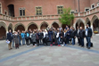
C9 C10 |  | visiting (Auschwitz Birkenau Museum) | 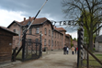
C9 C10 | 26th April | welcome meeting at school + presentations of schools | https://drive.google.com/drive/folders/0BxBr0FnPOqFKLW10R3dNTzQ1djA
C9 C10 |  | presentation of questionnaire analysis by project coordinator Giorgos Hlapanis | http://www.sifaplus.eu/en/safety/activities/item/363-presentation-of-questionnaire-analysis
C9 C10 |  | lecture and workshop run by FDN (Fundacja Dzieci Niczyje – organization cooperating with saferinternet.pl) (sexting and grooming) | http://www.sifaplus.eu/en/safety/activities/item/364-presentation-on-sexting-and-grooming-by-nobody-s-children-foundation
C9 C10 |  | workshops / writing articles / work in groups - creating websites on weebly.com | http://www.sifaplus.eu/en/safety/activities/item/365-workshops-creating-websites
C9 C10 |  | integration evening at school (food prepared by students and host families)+ Talent Night | http://www.sifaplus.eu/en/safety/activities/item/366-integration-evening-talent-night
C9 C10 | 27th April | Museum of Warsaw Uprising | 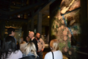
C9 C10 |  | lecture at Polish-Japanese University of Computer Technologies in Warsaw | http://www.sifaplus.eu/en/safety/activities/item/368-lecture-at-polish-japanese-academy-of-information-technology
C9 C10 |  | guided tour round the Old Town and Krakowskie Przedmiescie | 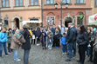
C9 C10 | 28th April | workshops (working on the websites, writing articles) - creating websites on weebly.com | http://www.sifaplus.eu/en/safety/activities/item/365-workshops-creating-websites
C9 C10 |  | Apple Competition | http://www.sifaplus.eu/en/safety/activities/item/367-apple-competition
C9 C10 |  | lecture (by ALTER) (on cyberbullying and cyberstalking) | http://www.sifaplus.eu/en/safety/activities/item/361-presentation-on-cyberbullying-by-alter
C9 C10 |  | workshops (finalizing the websites) | http://www.sifaplus.eu/en/safety/activities/item/365-workshops-creating-websites
C9 C10 | 29th April | presentation of results, presenting certificates | 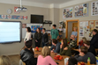
C9 C10 |  | visiting the Chopin Museum | 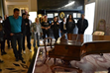
C9 C10 |  | Museum of Technology at the Palace of Science and Culture | 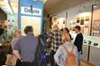
C9 C10 | 30th April | Evaluation of the meeting | https://drive.google.com/file/d/0B6i1EVWz6r7mTjVZRjVjS1hJajA/view?usp=sharing

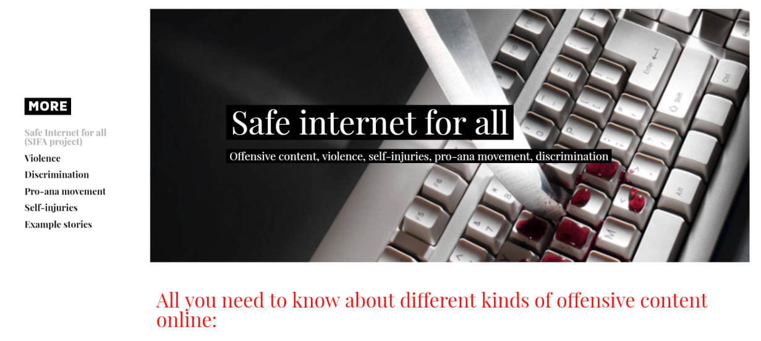
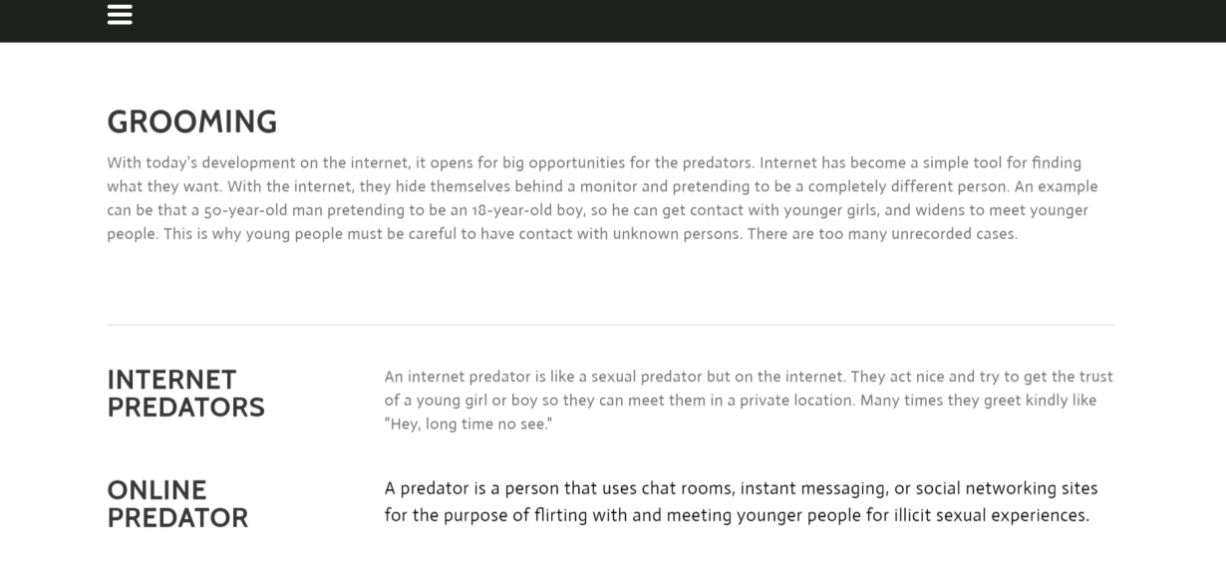
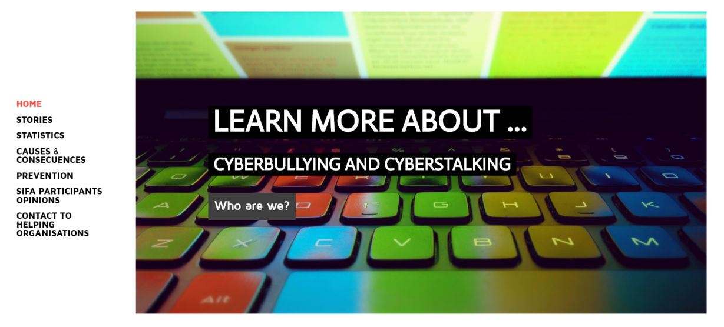
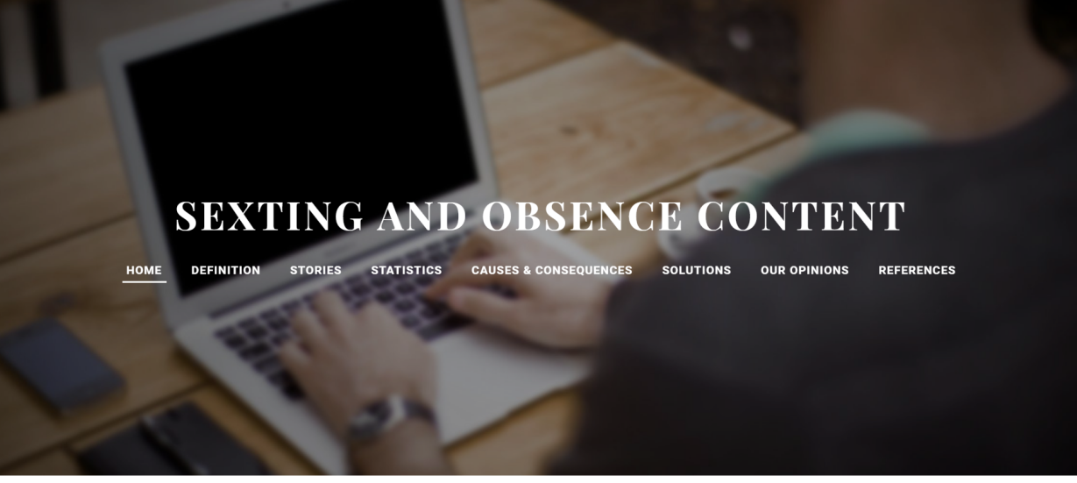
Licence Άδεια
Our SIFA project has officially ended. Yet, we relevant follow up activities will continue for at least two more years and especially dissemination activities for the results and products that have been created. We would like to thank all students, teachers, parents, organisations and scientists/guests that participated in some way and helped us during the project implementation.
The project is now under evaluation by the Greek National Agency and the products presented might be submitted to some change. Yet, meanwhile, we would like to present the Final Products of this 2 year collaboration, for which we are proud of and have been produced by all participants in SIFA. If they are submitted to changes, the current version will be updated by the revised versions.
Anybody can use the material produced during SIFA implementation, as long as they mention the Erasmus+ Project SIFA and that the products have been created by EU Erasmus+ funding.

The attachments (SIFA products) are licensed under a Creative Commons Attribution 4.0 International License and have been created during the implementation of the Erasmus+ Safe Internet For All (2014‐1‐EL01‐KA201‐001294) project.
Τα προϊόντα που ακολουθούν έχουν άδεια Creative Commons Αναφορά Δημιουργού - Παρόμοια Διανομή 4.0 Διεθνές και έχουν δημιουργηθεί στο πλαίσιο του προγράμματος Erasmus+ Safe Internet For All (Ασφαλές Διαδίκτυο για όλους - Σύμπραξη αποκλειστικά μεταξύ σχολείων με κωδικό 2014‐1‐EL01‐KA201‐001294)

