What is the mentioned phenomenon exactly?
You don’t give a damn about your friends and family, and you are looking for a persistent way to spend your time wisely? Then online gambling is the thing for you! You can earn a lot of money, which you can also lose but you don’t care about this either, right? Just focus on the positive aspects like …
- Big houses
- Fancy cars and women (You’ll get all the women, trust us. If you already have a wife or girlfriend, the more the better. If you are a woman consider it the other way around)
- Travelling to space (why not?)
- Buying an island
Negative aspects …
- None (trust us)
Don’t worry about your real friends, online friends are more reliable and much cooler

Addressing our young readers!
Are you tired of being an ungrateful little brat living off your parents’ income?
Start gambling, become independent and fulfill your dreams!
Do not trust the negative diagrams, they will only hinder you on your way to the top!!

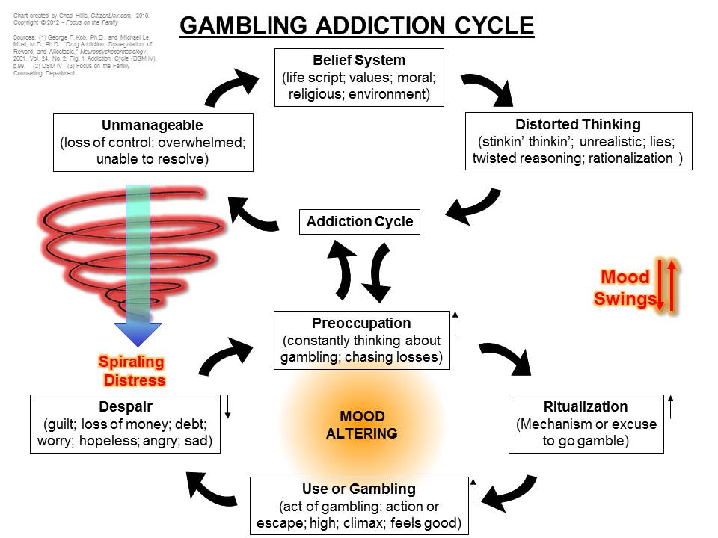
Example of what not to trust
Rather trust our professional
and trustworthy Diagram/Guide
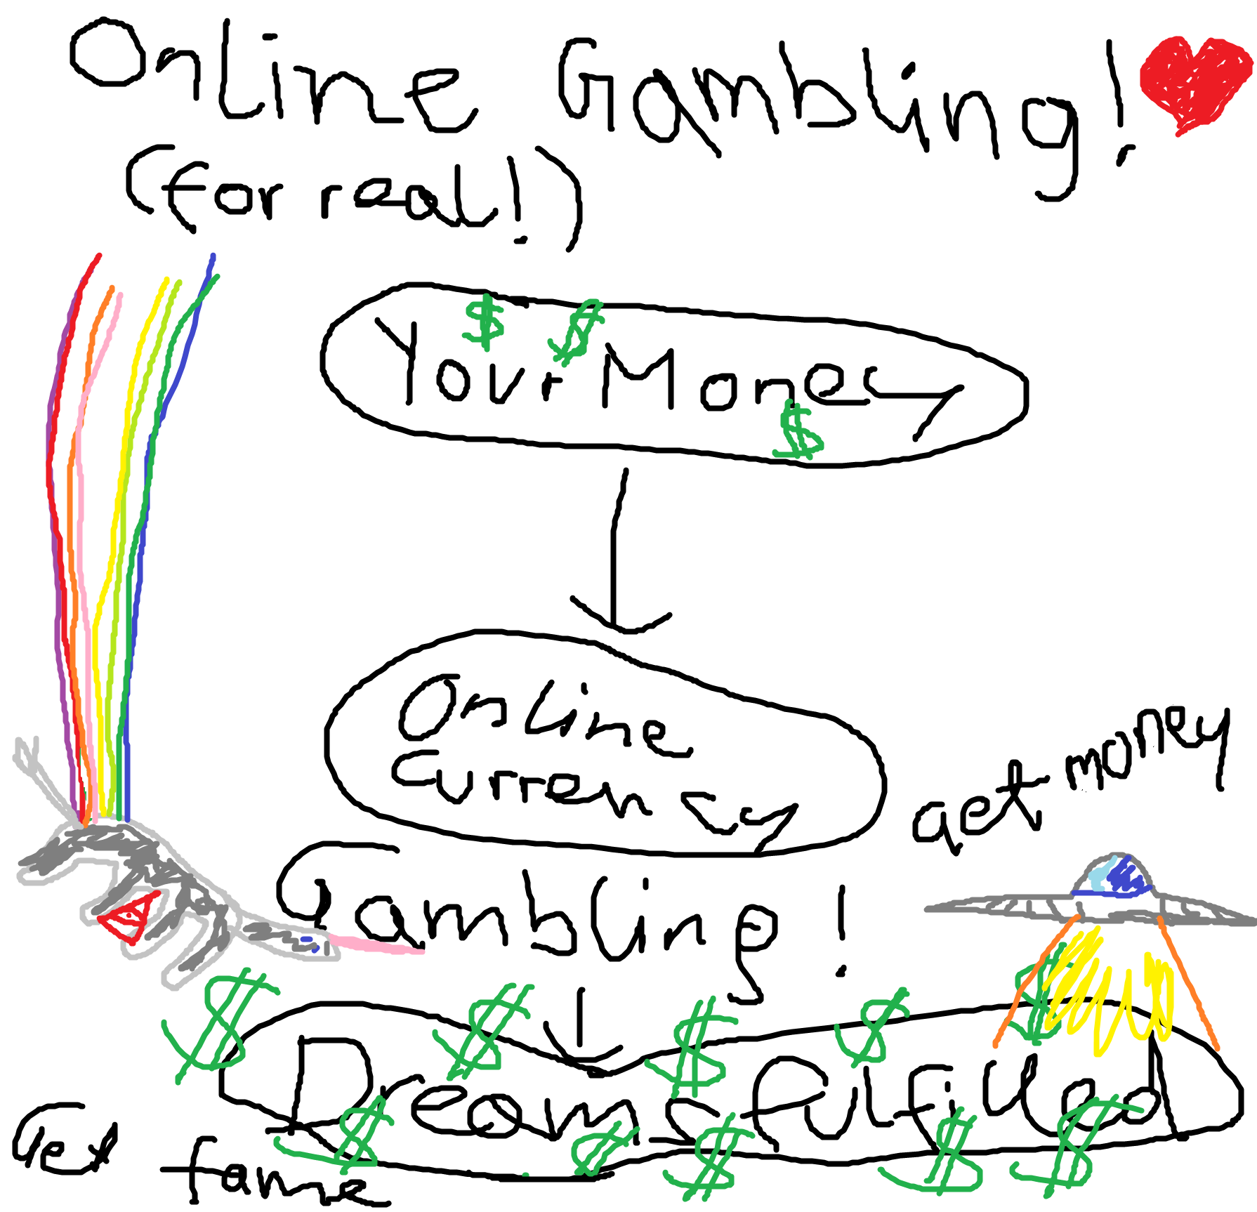

Admit that you don’t have a problem
The first step to successfully becoming an online addict lies in refusing you have a problem.
Isolate yourself and postpone everything except for gambling
Try to lock yourself in a room and block off any ways people could possibly use to help you. Ignore your everyday duties and your need for sleep and food and/or else. Pee in a bottle. Do not do anything else than gambling, even if you shouldn’t have money.
Don’t let anyone know
It’s just you and your gambling device, baby. Don’t let others set your relationship to risk.
Never keep control of yourself
Whenever you feel the urge to gamble. Just do it. Nobody cares.
Always try to improve your gambling
You should push yourself and your wallet to the limit. Think of new ways to gamble and use them excessively right away. It’s also important to bet higher and higher amounts of cash to make sure you will never regain control of your life.

- Have you ever had trouble controlling your urge to gamble?
- Can you walk away at will?
- Have you ever tried to borrow money to support the gambling habit? Have you ever lost your job because of it?
- Have you ever lost a close friend or a significant other because of gambling?
- Are your friends and family concerned and worried about how often you gamble and how much you spend when you gamble?

If not, try harder!

