The events mentioned below took place with a view to disseminating the results of the project. The activities were carried out by the teachers and students involved in the given tasks. The target audience of the dissemination process varied. Tasks and products were also disseminated more widely among those students and teachers who were not directly involved in the project activities. The outcomes were publicized not only to the pupils and teachers in the schools but also to people outside the project: parents, other schools, local community, nonprofit organizations related to teenagers and addictions, organizations all over the country, even the Ministry of Education. In this way we tried to broaden the target group that will feel the impact of the project. The project outcomes were shared with other schools in the region of each partner school. The resources which were mostly used were school meetings, presentations within each school partner, posters, graphs and figures, statistics, website of the project, links in every school website to the website of the project, dissemination days for parents, teachers, media, press and local television as well as innovative means of dissemination, such as the SIFA website specifically created for and especially devoted to the project updated continuously and including information about the activities, guidelines, presentations, articles from students, research results analyzed through SPSS, publications available in downloads for easier access to results. The SIFA twinspace was also used to disseminate the idea s of the project. We made sure that the project’s results are widely available for at least two years after the completion of the project. There will be open access to all resources that were developed. The results still continue to evolve and improve since all the needed tools remain active. The project has also been disseminated through National Agencies that appreciated the quality of the project’s results (examples of good practice).

Austria
A1  Austria | November 14th/15th 2014 | presentation of the SIFA project plans during open day at school centre | https://www.facebook.com/hak.has.ybbs?fref=nf

A1 Austria | November 6th | first introduction of SIFA on school’s facebook page | https://www.facebook.com/hak.has.ybbs?fref=nf

A4 Austria |  | Newspaper article in major local paper | http://www.sifaplus.eu/de/sucht/artikel/item/68-newspaper-article
A4  Austria | December  11th | reception’s at the mayor’s office in the city of Ybbs | https://www.facebook.com/hak.has.ybbs?fref=nf
A4 Austria | December 12 | publication during Austria event on school’s Facebook page | https://www.facebook.com/hak.has.ybbs?fref=nf
A4 Austria |  | postings on school’s Facebook page about SIFA - exchange in Austria | http://www.sz-ybbs.ac.at/~sz-ybbs/news/archiv/archiv-einzelnews/eu-erasmus-projekt-safe-internet-for-all/e1e3a1611ccf8503c679fe4e16eabf1d/
A4 Austria |  | students from the SIFA group presented project to classes at school
A4 Austria | February | Link on school website to SIFAplus.eu established | www.sz-ybbs.ac.at

A4 Austria | March 2015 | publication of Project Safe Internet Day in the official magazine of the city of Ybbs | http://www.ybbs.gv.at/fileadmin/user_upload/Ausgabe_3.pdf
A4 Austria | 27th February | Safe Internet Day project “24 hours without Internet” introduced on school’s facebook page | https://www.facebook.com/hak.has.ybbs?fref=nf

A4 Austria | February 23rd | Article published in NÖN (major regional paper) reporting about SAFE INTERNET DAY ACTIVITIES
A4 Austria | February  13th | article on Safe Internet Day school’s website | http://www.sz-ybbs.ac.at/~sz-ybbs/news/archiv/archiv-einzelnews/safe-internet-day-2015/b927081995a0b3e9d4c075432ed375a5/

A4 Austria | May | Presentation of Sweden results by participants to other students at school
A4 Austria | April 20th | Post of Sweden meeting result on school’s Facebook page | https://www.facebook.com/hak.has.ybbs?fref=nf
A4 Austria | April 14th | Link of SIFA Facebook page on school’s facebook page | https://www.facebook.com/hak.has.ybbs?fref=nf
A4 Austria | April 12th | Post during SIFA event in Sweden on school’s facebook page | https://www.facebook.com/hak.has.ybbs?fref=nf
A5 Austria | April 2016 | Post during SIFA event in Facebook
A5 Austria | April 2016 | Post during SIFA event in Facebook
A5 Austria | April 2016 | Report on website sz-ybbs

A4 Austria | 12 February 2016 | Mentioning on 2 websites of Safer Internet Workshop for students of secondary school Oberndorf organised by students from HAK Ybbs | http://www.nmsoberndorfandermelk.at/galerie/  http://www.sz-ybbs.ac.at/~sz-ybbs/news/archiv/archiv-einzelnews/safer-internet-workshop-an-nms-oberndorfmelk-4102/
A5  Austria | 12 April 2016 | Mentioning of “Safe online training for female farmers” by students on 2 websites | http://www.sz-ybbs.ac.at/~sz-ybbs/news/aktuell/einzelnews/multi-media-kurs-fuer-die-baeuerinnen-4130/  https://www.baeuerinnen-noe.at/?+Multi+Media+Kurs+fuer+die+Baeuerinnen+&id=2500%2C2408844%2C%2C
 | 17 November 2016 | Presentation of SIFA project at e-twinning event in Dublin/Ireland

Norway

A2 Norway | 21/11/2014 | Meeting with students about preparation for Austria and at the end of the meeting one of the local newspapers came to interview the students about the exchange and the project in general. | http://www.midtsiden.no/til-ybbs-sifa

A3 Norway | January 2015 | We were planning to have a day at school with no Internet, but because of a storm in our area many students were without the Internet and power for days. We used this event and had a questionnaire about their feelings being without Internet for days. | http://www.sifaplus.eu/en/addictions/articles/item/131-no-internet-for-hours-or-days
A4 All | December 2014 to  April 2015 | Dissemination for Austria
A4 Norway | December 2014 and January 2015 | Postings on the school’s Facebook page about the SIFA exchange in Austria | https://www.facebook.com/134531669930162/photos/a.751298924920097.1073741828.134531669930162/759830710733585/?type=1&theater  https://www.facebook.com/134531669930162/photos/a.751298924920097.1073741828.134531669930162/761188133931176/?type=1&theater
A4 Norway | December 2014 | One of the students who went to Austria presented the project and the exchange to the student council. | http://www.sifaplus.eu/en/addictions/articles/item/113-student-council-meeting-in-norway-what-did-we-do-in-austria

A5 Norway | 08,05,15 | The school newsletter wrote about the SIFA-day at school. | 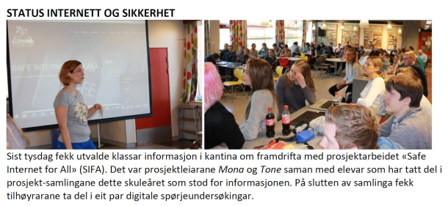

C3 C4  Norway | 11th February 2015 | Media coverage of the visit in Norway about the project and the Safer Internet Day we had during the week in Norway. | http://www.midtsiden.no/eit-tryggare-internett

A4 Norway | March 2015 | The students talked in class about health problems connect to Internet use.

A4 Norway | April 2015 | The students wrote about their experience in Sweden | http://www.sifaplus.eu/en/security/articles/item/272-the-norwegian-students-experiences-in-sweden

A4  Norway | Thursday February 25,2016 | Meeting with the Department of Education and Training in Hordaland Fylkeskommune. At this meeting we presented the project and what we have done so far. Two of the students, who have participated in the project (Malene and Henrik) presented their experiences and what they have learned. In addition to this, Tone and Mona talked about the project in general and how this has helped us in our work as teachers. | 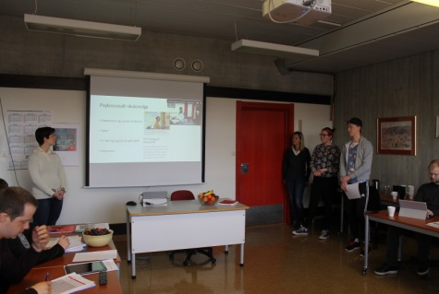  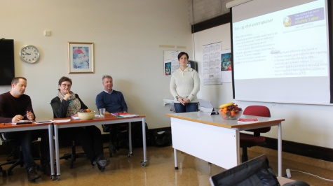

A4 Norway | 18.05.16 | Presentation by the students of webpages made in Poland | http://www.sifaplus.eu/en/safety/articles/item/374-sifa-day-in-norway
A4 Norway | 18.05.16 | Meeting with the anti-bullying representative from our county to tell about the project. | http://www.sifaplus.eu/en/safety/articles/item/374-sifa-day-in-norway

Greece

A1 All | September  To  October 2014 | General Preparation of project  The contact person announces the approval of the project to the school and the local community  - The local media is informed about the launch of the project  - Students and staff are informed about the existing project site on etwinning.net and adding members  -Parents are informed about the project

A1 Greece | October 2014 | Informing school community, media, municipality, etc. about the project and its goals.  Paper from school sent to all by email, uploaded to school site, sent to Educational Authorities in Region. | http://safeinternetforall.pbworks.com/w/file/fetch/88725449/%CE%95%CE%9D%CE%97%CE%9C%CE%95%CE%A1%CE%A9%CE%A3%CE%97%20%CE%93%CE%99%CE%91%20%CE%A4%CE%9F%20%CE%A0%CE%A1%CE%9F%CE%93%CE%A1%CE%91%CE%9C%CE%9C%CE%91%20ERASMUS%2B.pdf

M1 Greece | 10/11/2014 | Creation of site | http://www.sifaplus.eu/en/
M1 Greece | 10/11/2014 | Creation of Facebook group for teachers | https://www.facebook.com/groups/897480933595876/
M1 Greece | 10/11/2014 | Creation of Facebook group for students | https://www.facebook.com/groups/1716425405249800

A3 Greece | 1/1/2015 | Video created by Greek team with impressions and highlights of visit to Austria | http://www.sifaplus.eu/en/addictions/gallery/item/59-impressions-from-austria-by-the-greek-team

A3 Greece | 16/1/2015 | Views and impressions about what took place in Austria (from the Greek team). views expressed by the Greek students that participated in the meeting were presented in sites (sifa and school site) | http://www.sifaplus.eu/en/addictions/articles/item/86-views-greek-team

A4  Greece | 23/12/14 | Students presented to students of 2nd Lyceum of Kos work done in Austria and other matters relevant to Safe Internet For All, thus declaring the day an unofficial SIFA day | http://www.sifaplus.eu/en/addictions/articles/item/203-sifa-day-in-greece
A4  Greece | 27/2/2015 | A group of 3 students of the 2nd Lyceum of Kos (Greece) visited another lower High School of the district (2nd High School of Kos) in order to present to the younger students their work about safety and especially Grooming. They also talked with the students and informed them about the dangers. | http://www.sifaplus.eu/en/safety/articles/item/198-dissemination-activities-students-teaching-other-students-in-greek-schools
A4  Greece | 25/2/2015 | A group of 4 students of the 2nd Lyceum of Kos (Greece) visited another primary school of the district in order to present to the younger students their work about internet addictions, things that were dealt with in Austria. They also talked with the students and informed them about the dangers. | http://www.sifaplus.eu/en/safety/articles/item/198-dissemination-activities-students-teaching-other-students-in-greek-schools
A4  Greece | 4/2/2015 | Students presenting/talking to other students about Internet Addiction (4th Primary School of Kos). Students from the 2nd Lyceum of Kos have been engaged in presenting problems related to Internet Addiction to other students. | http://www.sifaplus.eu/en/addictions/articles/item/123-students-presenting-talking-to-other-students-about-internet-addiction

A4 Greece | 1/1/2015 | Video created by Greek team with impressions and highlights of visit to Austria. Presented in school, uploaded in youtube, in sifa site, in school site, presented to the local media. | http://www.sifaplus.eu/en/addictions/gallery/item/59-impressions-from-austria-by-the-greek-team

C3 C4  Norway | 11th February 2015 | Media coverage of the visit in Norway about the project and the Safer Internet Day we had during the week in Norway. | http://www.midtsiden.no/eit-tryggare-internett

A3 Greece | September 2014 to June 2015 | Special lessons in curriculum about projects and especially SIFA erasmus+.  Delivered by Athina Minaidi.  Creation of several projects by students.

A3 Greece | September 2014 to June 2015 | Special lessons in curriculum about projects and especially SIFA erasmus+.  Delivered by Hlapanis Giorgos.  Creation of several projects by students. | Download application  SIFA application for Android  http://www.google.com/url?q=http%3A%2F%2Fwww.sifaplus.eu%2Fen%2Fitem%2Fdownload%2F31_6556fdd2e48cf052c8f42aa24d87a85a&sa=D&sntz=1&usg=AFQjCNFYQuM21-tbuPoi1n1qDxBgR1cTEw

A4 All | February 2015 to  June 2015 | Dissemination for Norway
A4 Greece | 17/3/2015 | Presentation of activities held in Norway to students of 2nd Lyceum of Kos. | http://www.sifaplus.eu/en/health/gallery/item/231-meeting-in-norway
A4 Greece | 20/2/2015 | On Friday 20 February the Greek team who visited Os in Norway presented highlights of the meeting in Norway.The teachers of 2nd Lyceum of Kos were informed about the journey, the activities and the workshops of the program, accommodation conditions, the partners’ schools, the educational system of Norway, how ICT is integrated in teaching in Norwegian schools and last but not least the results and the conclusions of the meeting | http://www.sifaplus.eu/en/health/articles/item/183-dissemination-activities-norway-meeting-2nd-lyceum-of-kos
A4 Greece | 26/2/2015 | Presentation of results in conference in Heraklion Greece | https://drive.google.com/file/d/0B6i1EVWz6r7mR2JjdW1Vc3ZmRU0/view?usp=sharing  https://drive.google.com/file/d/0B6i1EVWz6r7mOXFHRG9scHN2ZDQ/view?usp=sharing  https://docs.google.com/presentation/d/1MBJ_FnCLvvaX1eZyIbmHOObXrD0lDeWl0CKCU5q_T3E/edit?usp=sharing  http://www.sifaplus.eu/en/health/results/item/283-presentation-of-sifa-results-in-conference-in-heraklion-greece  https://www.youtube.com/watch?v=Q7pAmFMGKwY  https://www.youtube.com/watch?v=Q7pAmFMGKwY

A4 All | April 2015 to  June 2015 | Dissemination for Sweden
A4 Greece | April 2015 | Informing boarding of teachers about the visit to Swedish Council for Higher Education | http://www.sifaplus.eu/el/syst/activities/item/267-visiting-swedish-council-for-higher-education
A4 Greece | April 2015 | Dissemination Activity after meeting in Sweden in 2nd Lyceum of Kos.  A group of students of the 2nd Lyceum of Kos (Greece) prepared a study about MALWARE, the categories and how we can protect our data. | http://www.sifaplus.eu/en/security/articles/item/269-dissemination-activity-malware
A4 Greece | April 2015 | Dissemination Activity after meeting in Sweden in 2nd Lyceum of Kos.  A group of students of the 2nd Lyceum of Kos (Greece) presented a study about MALWARE, the categories and how we can protect our data.

A4 Greece | April 2015 | Dissemination Activity after meeting in Sweden in 2nd Lyceum of Kos.  A group of students of the 2nd Lyceum of Kos (Greece) presented a study about VIRUS. | http://www.sifaplus.eu/en/security/articles/item/279-dissemination-activity-malware
A4 Greece | April 2015 | Dissemination Activity after meeting in Sweden in 2nd Lyceum of Kos.  A group of students of the 2nd Lyceum of Kos (Greece) presented a study about DARK NET. | http://www.sifaplus.eu/en/security/articles/item/278-dark-net-a-study-from-students-of-the-2nd-lyceum-of-kos
A4 Greece | April 2015 | Dissemination Activity after meeting in Sweden in 2nd Lyceum of Kos.  A group of students of the 2nd Lyceum of Kos (Greece) presented SIFA site to other students. http://www.sifaplus.eu | http://www.sifaplus.eu/en/security/articles

A4 Greece | April 2015 | A group of students of the 2nd Lyceum of Kos (Greece) presented a study about Plagiarism, the categories and how we can avoid it. | http://www.sifaplus.eu/en/ethics/articles/item/270-plagiarism
A4 Greece | April 2015 | A group of students of the 2nd Lyceum of Kos (Greece) presented a study about Internet Piracy. | http://www.sifaplus.eu/en/ethics/articles/item/268-internet-piracy
A4 Greece | June 2015 | Video with memories from meeting in Sweden | http://www.sifaplus.eu/en/security/gallery/item/277-memories-from-meeting-in-sweden

A2 Greece | 30 July 2015 | Meeting with teachers, parents and students of SIFA | Pairing of students (https://docs.google.com/spreadsheets/d/1fdYhupy4gpTM-V0_WZU-oY2DfMJPu77D6V4k6Bd1WBY/edit?usp=sharing)  Tasks (https://drive.google.com/file/d/0B6i1EVWz6r7md3k5SFJTWFR0ZkU/view?usp=sharing)  Program (https://drive.google.com/file/d/0B6i1EVWz6r7mY1Y5VjV3bjdJMFE/view?usp=sharing)  Arrangement of participation  Arrangement of fulfilment of tasks  Arrangement of rules of hosting  Arrangement of transportation
A2 Greece | June to August 2015 | Dissemination | emails and invitations to experts  To Greek Police  To Greek Archaeological Institution  To Municipality of Kos  To Mr. Zaharias  To Press and media

A3 Greece | October 2015 | Discussion with students about the project in the presence of a reporter | Creation of a movie presenting the results in district and local TV.
A3 Greece | November 2015 | Submission of paper presenting overall work in project until now | 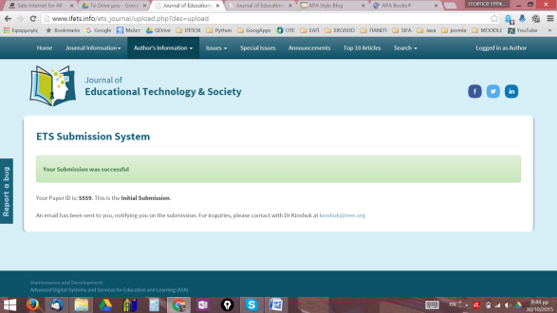

A3 Greece | October 2015 to November 2015 | Creation of video about the meeting in Greece and the learning activities (during School Project by teacher Hlapanis G.) | https://youtu.be/3qZiSiSlLEE  http://www.sifaplus.eu/en/ethics/gallery/item/339-video-about-safe-internet-for-all-meeting-in-greece-about-ethics
A3 Greece | October 2015 to January 2016 | Creation of video about the meeting in Greece and the learning activities (during School Project by teacher Hlapanis G.) | https://youtu.be/3qZiSiSlLEE  http://www.sifaplus.eu/en/ethics/gallery/item/340-video-about-safe-internet-for-all-meeting-in-greece-about-ethics-2nd

A3 Greece | 25 November 2015 | 1st Primary School of Kos  Students visit the primary school and talk with other students about internet safety, show videos, presentations, etc.  photos:  https://goo.gl/photos/EJ2c8WjHABkF575w6 | Presentation of video created by students  https://youtu.be/3qZiSiSlLEE  http://www.sifaplus.eu/en/ethics/gallery/item/339-video-about-safe-internet-for-all-meeting-in-greece-about-ethics  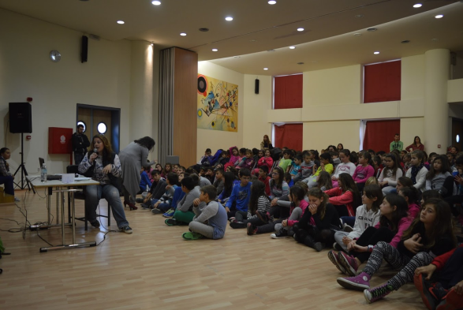
A3 Greece | 1 December 2015 | 1st High School of Kos  Students visit the primary school and talk with other students about internet safety, show videos, presentations, etc.  activities:  https://drive.google.com/folderview?id=0B6i1EVWz6r7mNmZ5RlJlSHRmYTg&usp=sharing  photos:  https://goo.gl/photos/XBKY7GvhZtMjWJs98 | Presentation of video created by students  https://youtu.be/3qZiSiSlLEE  http://www.sifaplus.eu/en/ethics/gallery/item/339-video-about-safe-internet-for-all-meeting-in-greece-about-ethics  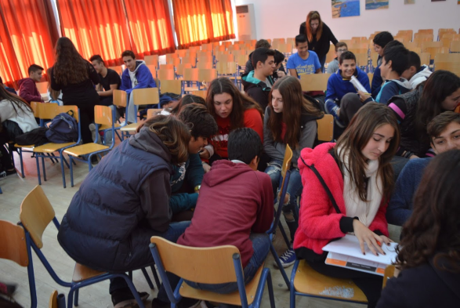
A3 Greece | 11 December 2015 | 1st High School of Kos  Students visit the primary school and talk with other students about internet safety, show videos, presentations, etc.  2nd visit within 10 days.  photos:  https://goo.gl/photos/bpbRPoJ61Xbau3eK6  activities:  https://drive.google.com/folderview?id=0B6i1EVWz6r7mNmZ5RlJlSHRmYTg&usp=sharing | Presentation of video created by students  https://youtu.be/3qZiSiSlLEE  http://www.sifaplus.eu/en/ethics/gallery/item/339-video-about-safe-internet-for-all-meeting-in-greece-about-ethics  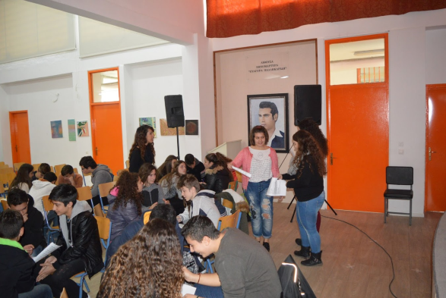

A3 Greece | 6 December 2015 | SIFA DAY for parents at school. Parents were invited. Presentations by students and Psychologist Maria Drosou, movies and discussions took place. | https://drive.google.com/folderview?id=0B6i1EVWz6r7mVnhJeDhpSnhZbEU&usp=sharing
A3 Greece | 28 Feb 2015 | 2nd Lyceum of Kos with parents of students aged 15-18 from all schools of the region and teachers. Presentations, relevant videos and discussion. | Presentation by Drosou Maria https://youtu.be/uXR3TGSB-80  Presentation by Hlapanis Georgios  https://youtu.be/DHCpj_QkkxU
A4 All | October 2015 to  January 2016 | Dissemination for Greece
A4 Greece | 19 October 15 | Presentation of SIFA administration, management and results at Greek National Agency (IKY) | Presentation:  https://drive.google.com/file/d/0B6i1EVWz6r7maWZ6Y2RpYl9qV1k/view?usp=sharing
A4 Greece | October and November 2015 | Uploading Evidence of our activities in eSafety label site  Research analysis Ethics  Workshop about research analysis  Presentation of students  Presentation of Creative Commons  Workshop with activites from www.webwewant.eu  Kahoot game  https://play.kahoot.it/#/?quizId=3864f024-2f20-4023-bd1e-68d691968f09  Activity Kahoot students playing game  Translation of decision trees  https://drive.google.com/folderview?id=0B6i1EVWz6r7mSHdYZFRuSzlNc3c&usp=sharing  Teleconferencing with Aris Louvris and Greek Police Expert Mrs Groustidou  Presentation from Maria Drosou psychologist about online behaviour  Presentation about plagiarism by Hlapanis Giorgos and workshop  Plagiarism Checking activity  https://drive.google.com/a/2lykko.gr/folderview?id=0B6i1EVWz6r7mT2ptRXBnRzRMR00&usp=sharing#  Presentation at the University of the Aegean about Plagiarism policy  Kopidakis Giannis presents about online behaviour in Social networks | http://www.esafetylabel.eu/group/teacher/my-school-area  https://docs.google.com/document/d/1qt-UbqHqLfUBDYW6PtMJZXfNw4uKT2sVSGNo3DtJizE/edit  https://drive.google.com/a/2lykko.gr/folderview?id=0B6i1EVWz6r7mMkpPb2hQTks1T1U&usp=sharing#  https://drive.google.com/a/2lykko.gr/folderview?id=0B6i1EVWz6r7meFZyM0xlVWQ2S3c&usp=sharing#  https://drive.google.com/folderview?id=0B6i1EVWz6r7mdFRULUVFd1pwSlk&usp=sharing  https://drive.google.com/folderview?id=0B6i1EVWz6r7mX2VoemY2dU9mdmM&usp=sharing  https://play.kahoot.it/#/?quizId=3864f024-2f20-4023-bd1e-68d691968f09  https://drive.google.com/folderview?id=0B6i1EVWz6r7mQXhJSlNsaGw3aW8&usp=sharing  https://drive.google.com/a/2lykko.gr/folderview?id=0B6i1EVWz6r7mYkFCYllUN1c4T28&usp=sharing#  https://drive.google.com/folderview?id=0B6i1EVWz6r7mY3lWNnFNaVZ0VTg&usp=sharing  https://drive.google.com/folderview?id=0B6i1EVWz6r7mSlhZRWNDWFRnTnM&usp=sharing  https://drive.google.com/folderview?id=0B6i1EVWz6r7mRlh5Mi1MVFhpNEk&usp=sharing  https://drive.google.com/a/2lykko.gr/folderview?id=0B6i1EVWz6r7mT2ptRXBnRzRMR00&usp=sharing#  https://drive.google.com/folderview?id=0B6i1EVWz6r7mOG5ucjB0dGZsVlU&usp=sharing  https://drive.google.com/a/2lykko.gr/folderview?id=0B6i1EVWz6r7mT2ptRXBnRzRMR00&usp=sharing#
A4 Greece | October 2015 | Informing Press, Social Networks and local community about the meeting and results | 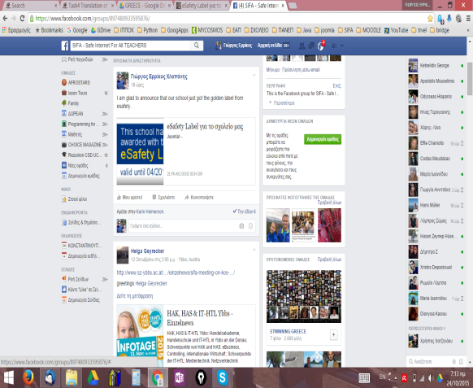
A4 Greece | October 2015 | Discussion with students about the project in the presence of a reporter | Creation of a movie presenting the results in district and local TV.

A4 Greece | November 2015 | Submission of paper presenting overall work in project until now
A4 Greece | November 2015 | Reportage TV and news site Aegean TV  http://www.kosvoice.gr/  https://www.youtube.com/watch?v=ESMjUcWKe4o  http://www.sifaplus.eu/en/ethics/results/item/335-tv-reportage-about-meeting-in-greece | 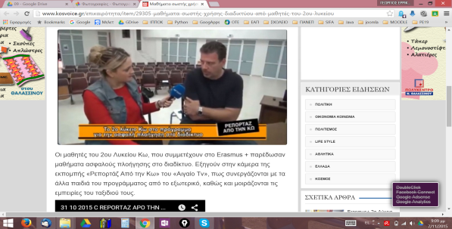
A4 Greece | October 2015 to November 2015 | Creation of video about the meeting in Greece and the learning activities (during School Project by teacher Hlapanis G.) | https://youtu.be/3qZiSiSlLEE  http://www.sifaplus.eu/en/ethics/gallery/item/339-video-about-safe-internet-for-all-meeting-in-greece-about-ethics
A4 Greece | October 2015 to January 2016 | Creation of video about the meeting in Greece and the learning activities (during School Project by teacher Hlapanis G.) | https://youtu.be/3qZiSiSlLEE  http://www.sifaplus.eu/en/ethics/gallery/item/340-video-about-safe-internet-for-all-meeting-in-greece-about-ethics-2nd
A4 Greece | 6 December 2015 | SIFA DAY for parents at school. Parents were invited. Presentations by students and Phsycologist Maria Drosou, movies and discussions took place. | https://drive.google.com/folderview?id=0B6i1EVWz6r7mVnhJeDhpSnhZbEU&usp=sharing

A3 Greece | 6 December 2015 | SIFA DAY for parents at school. Parents were invited. Presentations by students and Psychologist Maria Drosou, movies and discussions took place. | https://drive.google.com/folderview?id=0B6i1EVWz6r7mVnhJeDhpSnhZbEU&usp=sharing
A3 Greece | 28 Feb 2015 | 2nd Lyceum of Kos with parents of students aged 15-18 from all schools of the region and teachers. Presentations, relevant videos and discussion. | Presentation by Drosou Maria https://youtu.be/uXR3TGSB-80  Presentation by Hlapanis Georgios  https://youtu.be/DHCpj_QkkxU
A4 All | October 2015 to  January 2016 | Dissemination for Greece
A4 Greece | 19 October 15 | Presentation of SIFA administration, management and results at Greek National Agency (IKY) | Presentation:  https://drive.google.com/file/d/0B6i1EVWz6r7maWZ6Y2RpYl9qV1k/view?usp=sharing
A4 Greece | October and November 2015 | Uploading Evidence of our activities in eSafety label site  Research analysis Ethics  Workshop about research analysis  Presentation of students  Presentation of Creative Commons  Workshop with activites from www.webwewant.eu  Kahoot game  https://play.kahoot.it/#/?quizId=3864f024-2f20-4023-bd1e-68d691968f09  Activity Kahoot students playing game  Translation of decision trees  https://drive.google.com/folderview?id=0B6i1EVWz6r7mSHdYZFRuSzlNc3c&usp=sharing  Teleconferencing with Aris Louvris and Greek Police Expert Mrs Groustidou  Presentation from Maria Drosou psychologist about online behaviour  Presentation about plagiarism by Hlapanis Giorgos and workshop  Plagiarism Checking activity  https://drive.google.com/a/2lykko.gr/folderview?id=0B6i1EVWz6r7mT2ptRXBnRzRMR00&usp=sharing#  Presentation at the University of the Aegean about Plagiarism policy  Kopidakis Giannis presents about online behaviour in Social networks | http://www.esafetylabel.eu/group/teacher/my-school-area  https://docs.google.com/document/d/1qt-UbqHqLfUBDYW6PtMJZXfNw4uKT2sVSGNo3DtJizE/edit  https://drive.google.com/a/2lykko.gr/folderview?id=0B6i1EVWz6r7mMkpPb2hQTks1T1U&usp=sharing#  https://drive.google.com/a/2lykko.gr/folderview?id=0B6i1EVWz6r7meFZyM0xlVWQ2S3c&usp=sharing#  https://drive.google.com/folderview?id=0B6i1EVWz6r7mdFRULUVFd1pwSlk&usp=sharing  https://drive.google.com/folderview?id=0B6i1EVWz6r7mX2VoemY2dU9mdmM&usp=sharing  https://play.kahoot.it/#/?quizId=3864f024-2f20-4023-bd1e-68d691968f09  https://drive.google.com/folderview?id=0B6i1EVWz6r7mQXhJSlNsaGw3aW8&usp=sharing  https://drive.google.com/a/2lykko.gr/folderview?id=0B6i1EVWz6r7mYkFCYllUN1c4T28&usp=sharing#  https://drive.google.com/folderview?id=0B6i1EVWz6r7mY3lWNnFNaVZ0VTg&usp=sharing  https://drive.google.com/folderview?id=0B6i1EVWz6r7mSlhZRWNDWFRnTnM&usp=sharing  https://drive.google.com/folderview?id=0B6i1EVWz6r7mRlh5Mi1MVFhpNEk&usp=sharing  https://drive.google.com/a/2lykko.gr/folderview?id=0B6i1EVWz6r7mT2ptRXBnRzRMR00&usp=sharing#  https://drive.google.com/folderview?id=0B6i1EVWz6r7mOG5ucjB0dGZsVlU&usp=sharing  https://drive.google.com/a/2lykko.gr/folderview?id=0B6i1EVWz6r7mT2ptRXBnRzRMR00&usp=sharing#
A4 Greece | October 2015 | Informing Press, Social Networks and local community about the meeting and results
A4 Greece | October 2015 | Discussion with students about the project in the presence of a reporter | Creation of a movie presenting the results in district and local TV.
A4 Greece | November 2015 | Submission of paper presenting overall work in project until now
A4 Greece | November 2015 | Reportage TV and news site Aegean TV  http://www.kosvoice.gr/  https://www.youtube.com/watch?v=ESMjUcWKe4o  http://www.sifaplus.eu/en/ethics/results/item/335-tv-reportage-about-meeting-in-greece
A4 Greece | October 2015 to November 2015 | Creation of video about the meeting in Greece and the learning activities (during School Project by teacher Hlapanis G.) | https://youtu.be/3qZiSiSlLEE  http://www.sifaplus.eu/en/ethics/gallery/item/339-video-about-safe-internet-for-all-meeting-in-greece-about-ethics
A4 Greece | October 2015 to January 2016 | Creation of video about the meeting in Greece and the learning activities (during School Project by teacher Hlapanis G.) | https://youtu.be/3qZiSiSlLEE  http://www.sifaplus.eu/en/ethics/gallery/item/340-video-about-safe-internet-for-all-meeting-in-greece-about-ethics-2nd
A4 Greece | 6 December 2015 | SIFA DAY for parents at school. Parents were invited. Presentations by students and Phsycologist Maria Drosou, movies and discussions took place. | https://drive.google.com/folderview?id=0B6i1EVWz6r7mVnhJeDhpSnhZbEU&usp=sharing
A4 Greece | 28 Feb 2015 | 2nd Lyceum of Kos with parents of students aged 15-18 from all schools of the region and teachers. Presentations, relevant videos and discussion. | Presentation by Drosou Maria https://youtu.be/uXR3TGSB-80  Presentation by Hlapanis Georgios  https://youtu.be/DHCpj_QkkxU
A4 Greece | 6/3/2015 | Relevant article on sifaplus.eu site. | http://www.sifaplus.eu/en/safety/articles/item/352-sifa-day-in-greece-and-preparation-activities
A4 Greece | 24/3/2016 | Webinar for informatics teachers of Greece, presenting SIFA, matters related to Internet Safety, Research Results  http://blogs.sch.gr/webinarspe1920/2016/03/08/webinar2016004/  https://www.youtube.com/watch?v=rDEhE6QZP4Y&feature=youtu.be  42 άτομα παρακολούθησαν  Ανατολική Μακεδ. & Θράκη : 5  Κεντρική Μακεδονία : 8  Δυτική Μακεδονία : 0  Ήπειρος : 1  Θεσσαλία : 3  Ιόνιοι Νήσοι : 1  Δυτική Ελλάδα : 5  Στερεά Ελλάδα : 3  Αττική : 6  Πελοπόννησος : 0  Βόρειο Αιγαίο : 0  Νότιο Αιγαίο : 0  Κρήτη : 2  Εξωτερικό : 1 | https://docs.google.com/presentation/d/1FtqDqni4WZX_T7YsK-3E3V06SDcnrUr1yIiHo-myYxw/edit?usp=sharing  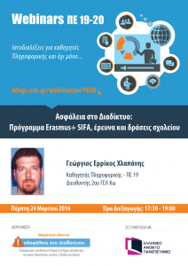
A4 Greece | 5/4/2016 | Visit to 7th Primary School of Kos - Presentation of SIFA and discussion about internet safety | Photos: https://goo.gl/photos/HbwARzkZN7XLjENm9  Presentation  https://drive.google.com/open?id=0B6i1EVWz6r7mTUhQeTZoM0gyWGM
A4 Greece | 11/4/2016 | Presentations at a seminar in Drama about SIFA, experience concerning internet Safety, Research results, etc.  https://goo.gl/photos/Xno2XEEPQZLJAFax7 | For parents:  https://docs.google.com/presentation/d/141M6XlrcAFRWo5071xKJbt4DTeaq4FMWeEYRPg6K2C4/edit?usp=sharing  And for teachers:  https://docs.google.com/presentation/d/1_FRQzXWHduYvy5WqAcuGmxUkIYEz4R8eBBNAwvxFMZE/edit?usp=sharing  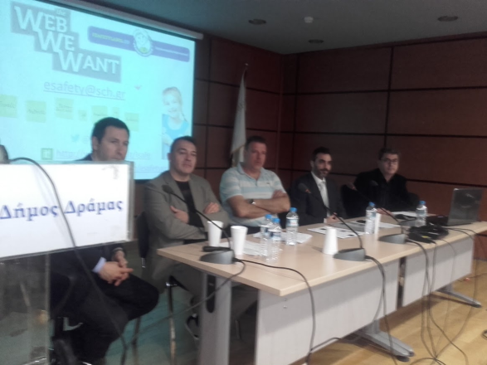
A4 Greece | 12/4/2016 | Interview at a radio station in Drama | About SIFA project, results, dangers of internet misuse, etc.

A4 All | April 2016 to  July 2016 | Dissemination for Poland
A4 Greece | 9 May 2016 | SIFA Day  Presentations, Games (kahoot), Interviews and filling in of Questionnaires by many students of the school.  2 Kahoot games:  https://play.kahoot.it/#/?quizId=e8245355-039f-4fa4-811e-f759dde4135f  https://play.kahoot.it/#/?quizId=aa1a26fb-00f4-4c4e-9750-44b780239c79 | https://goo.gl/photos/zftZXZVVfAbm19cf6  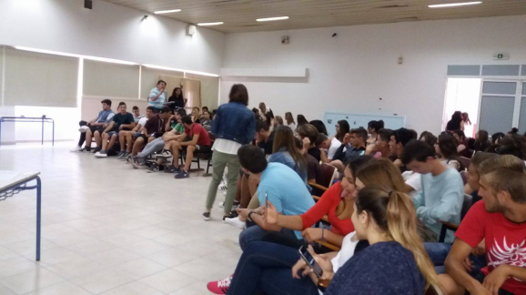
A5 All | April 2016 to  June 2016 | Further Teaching – Learning activities for Poland
A5 Greece | 9 May 2016 | SIFA Day  Presentations, Games (kahoot), Interviews and filling in of Questionnaires by many students of the school.  2 Kahoot games:  https://play.kahoot.it/#/?quizId=e8245355-039f-4fa4-811e-f759dde4135f  https://play.kahoot.it/#/?quizId=aa1a26fb-00f4-4c4e-9750-44b780239c79 | https://goo.gl/photos/zftZXZVVfAbm19cf6

Greece | May 2016 | Students’ video about Polish Meeting  https://youtu.be/AvLCcBZR3-Q

Poland

A1 Poland | Sept 2014 | The approval of the project is announced officially to the school community. The announcement is also sent to the regional council and local authorities. | Document signed by the Headteacher.

A1 Poland | 27th Sept 2014 | Informing the local authorities and educational council about the approval of the project | Official letter to the head of the regional government and educational council signed by the Headteacher

A1 Poland | October 2014 | Informing parents and a wider community about the approval of the project (during parental meeting and on the school website) | http://www.logrojec.pl/10-aktualnosci/70-rozpoczynamy-nowy-projekt-w-ramach-programu-erasmus

A4 All | December 2014 to  April 2015 | Dissemination for Austria
A4 Poland | Dec-Jan 2014 | Sending the summary of the project meeting to the local authorities, local schools and media (press): Zycie Grojca, Jablonka, Nad Wisla, Kurier Poludniowy, Oko, Okolica, grojec.pl, grojecmiasto.pl, Mazowsze Radio. | http://www.sifaplus.eu/en/addictions/articles/item/117-press-about-us
A4 Poland | 15th Dec 2014 | Polish students’ memories after the visit in Austria – presenting the activities and reflections. | http://www.sifaplus.eu/en/addictions/articles/item/46-polish-students-memories-sfter-the-visit-in-austria
A4 Poland | 16th Dec 2014 | Highlights from Austria – uploading pictures from the visit on SIFA site. | http://www.sifaplus.eu/en/addictions/gallery/item/49-highlights-from-austria
A4 Poland | Dec-Jan 2014 | Students who participated in the meeting give lectures to other classes and give a presentation on the fir visit topic (internet addictions) to the whole school community. | Document signed by the Headteacher

A4 Poland | 15th Jan 2015 | Parental meeting - during the meeting in the assembly hall the parents and teachers could watch a presentation on ‘Safe Internet For All’ project in the framework of Erasmus+ project. The audience were informed about all the work that has been done by the project participants, the products of the project and the follow-up steps to be  taken. | http://www.sifaplus.eu/en/addictions/articles/item/119-parental-meeting-l-o-grojec-poland

A3 Poland | Feb-Apr 2015 | Presentation on Health and visit in Norway – students who participated in the visit answered other students’ questions while presenting information to classes at LO | Lesson subjects in the digital register – confirmed by the Headteacher
A3 Poland | April 2015 | Creating a film on the visit in Norway and later on displaying it as part of dissemination process. | http://www.sifaplus.eu/en/health/gallery/item/239-visit-in-norway-highlights

A4 All | February 2015 to  June 2015 | Dissemination for Norway
A4 Poland | Feb 2015 | Sending the summary of the project meeting to the local authorities, local schools and media (press): Zycie Grojca, Jablonka, Nad Wisla, Kurier Poludniowy, Oko, Okolica, grojec.pl, grojecmiasto.pl, Mazowsze Radio. | http://twinspace.etwinning.net/2459/pages/page/25995
A4 Poland | Feb 2015 | Polish students’ memories after the visit in Norway – presenting the activities and reflections. | http://www.sifaplus.eu/en/health/articles/item/176-polish-students-memories-from-norway  http://www.sifaplus.eu/en/health/articles/item/177-the-meeting-programme-summary
A4 Poland | Feb 2015 | Highlights from Norway – uploading pictures from the visit on SIFA site. | http://www.sifaplus.eu/en/health/gallery/item/149-highlights-from-the-meeting-in-norway-pictures-by-polish-group
A4 | March 2015 | Making a video summarizing the meeting in Norway | http://www.sifaplus.eu/en/health/gallery/item/239-visit-in-norway-highlights
A4 Poland | Feb-Apr 2015 | Students and teachers who participated in the meeting give lectures to other classes and give a presentation on the visit topic (health) to the whole school community. | Document signed by the Headteacher, electronic register

A4 Poland | Feb 2015 | Parental meeting - the audience were informed about all the work that has been done by the project participants, the products of the project and the follow-up steps to be taken. | School report
A4 Poland | 9th April 2015 | A group of students from ZSP Jasieniec (local school) were informed about the main objectives of the project as well as the tasks and activities that have been performed so far. | http://www.sifaplus.eu/en/health/articles/item/238-dissemination-activity-in-lo-grojec

A3 Poland | Apr-May 2015 | Presentation on Security and visit in Sweden – students who participated in the visit answered other students’ questions while presenting information to classes at LO | pictures, school register, document signed by headteacher
A3 Poland | April 2015 | Creating a film on the visit in Sweden and later on displaying it as part of dissemination process. | http://www.sifaplus.eu/en/security/gallery/item/254-visit-in-sweden-trailer
A3 Poland | April-May 2015 | Students who participated in the meeting give lectures to other classes and give a presentation on the meeting topic to the whole school community. | pictures, school register, document signed by headteacher

A4 All | April 2015 to  June 2015 | Dissemination for Sweden
A4 Poland | Apr 2015 | Sending the summary of the project meeting to the local authorities, local schools and media (press): Zycie Grojca, Jablonka, Nad Wisla, Kurier Poludniowy, Oko, Okolica, grojec.pl, grojecmiasto.pl, Echo Dnia, Mazowsze Radio.
A4 Poland | Apr 2015 | Polish students’ memories after the visit in Sweden – presenting the activities and reflections. | http://www.sifaplus.eu/en/security/articles/item/255-logrojec-sweden-memories
A4 Poland | Apr 2015 | Highlights from Sweden – uploading pictures from the visit on SIFA site. | http://www.sifaplus.eu/en/security/gallery/item/256-short-term-visit-in-sweden-picture-gallery
A4 Poland | Apr-May 2015 | Students and teachers who participated in the meeting give lectures to other classes and give a presentation on the visit topic (security) to the whole school community. | Pictures, document signed by headteacher, school register with subjects of lessons

A4 All | April 2015 to  June 2015 | Dissemination for Sweden
A4 Poland | Apr 2015 | Sending the summary of the project meeting to the local authorities, local schools and media (press): Zycie Grojca, Jablonka, Nad Wisla, Kurier Poludniowy, Oko, Okolica, grojec.pl, grojecmiasto.pl, Echo Dnia, Mazowsze Radio.
A4 Poland | Apr 2015 | Polish students’ memories after the visit in Sweden – presenting the activities and reflections. | http://www.sifaplus.eu/en/security/articles/item/255-logrojec-sweden-memories
A4 Poland | Apr 2015 | Highlights from Sweden – uploading pictures from the visit on SIFA site. | http://www.sifaplus.eu/en/security/gallery/item/256-short-term-visit-in-sweden-picture-gallery
A4 Poland | Apr-May 2015 | Students and teachers who participated in the meeting give lectures to other classes and give a presentation on the visit topic (security) to the whole school community. | Pictures, document signed by headteacher, school register with subjects of lessons
A4 Poland | Apr 2015 | making a film summarizing the visit in Sweden and uploading it on You tube and SIFA site | http://www.sifaplus.eu/en/security/gallery/item/254-visit-in-sweden-trailer

A3 Poland | 5 Nov 2015 | Presentation on Ethics and visit in Greece – students who participated in the visit answered other students’ questions while presenting information to classes at LO | http://www.sifaplus.eu/en/ethics/articles/item/347-ethics-day-in-grojec
A3 Poland |  | Creating a photo presentation on the visit in Greece and showing it to the school community
A3 Poland | October – January 2016 | Students who participated in the meeting give lectures to other classes and give a presentation on the meeting topic as well as the other project topics to the whole school community. | http://www.sifaplus.eu/en/ethics/articles/item/348-dissemination-presentations-given-by-polish-students
A3 Poland | October 2015 | Preparing a presentation about the project (preparation for the meeting at NA) | http://www.sifaplus.eu/en/ethics/articles/item/337-dissemination-at-na-in-poland
 | October 2015 | Receiving an award for the winning of Selfie+ competition in two categories. Presenting the results of the project to teachers from all over Poland. | http://www.sifaplus.eu/en/security/articles/item/260-first-prize-in-poland-in-selfie-competition

A4 Poland | Oct 2015 to  Jan 2016 | Dissemination for Greece
A4 Poland | 7 Oct 2015 | Presentation of SIFA administration, management and results at the Polish National Agency. On 7th October 2015, the Polish coordinator Pawel Posnik, gave a presentation about SIFA project to the teachers from all over the country. The presentation was mainly about the topic of the project, dissemination of results, management and the products of SIFA project. | http://www.sifaplus.eu/en/ethics/articles/item/337-dissemination-at-na-in-poland
A4 Poland | October 2015 | School community is informed about the visit in Greece and its results | http://www.logrojec.pl/10-aktualnosci/120-bezpieczny-internet-dla-wszystkich-uczniowie-lo-w-grojcu-z-wizyta-w-grecji
A4 Poland | October 2015 | Sending the summary of the project meeting to the local authorities. | School reports
A4 Poland | October 2015 | Sending the summary of the project meeting to local schools and media (press): Zycie Grojca, Jablonka, Nad Wisla, Kurier Poludniowy, Oko, Okolica, grojec.pl, grojecmiasto.pl, Mazowsze Radio. | Newspaper articles
A4 Poland | 3 Nov 2015 | Parents’ meeting at school – more information about the SIFA project, its progress and results | School register
A4 Poland | 5 Nov 2015 | SIFA Day at school – articles about the event appear on the school webite and in the local media | http://www.sifaplus.eu/en/ethics/articles/item/347-ethics-day-in-grojec
A4 Poland | Oct 2015 | Polish students’ memories after the visit in Greece – presenting the activities and reflections. | http://www.sifaplus.eu/en/ethics/articles/item/327-thank-you-from-poland  http://www.sifaplus.eu/en/ethics/articles/item/349-dissemination-for-students  http://www.sifaplus.eu/en/ethics/articles/item/348-dissemination-presentations-given-by-polish-students
A4 Poland | Oct 2015 | Highlights from Greece – uploading pictures from the visit on SIFA site. | http://www.sifaplus.eu/en/ethics/articles/item/327-thank-you-from-poland
A4 Poland | 15 Jan 2015 | Parents’ meeting at school – more information about the SIFA project, its progress and results | School register

A5 Poland | Jan 2016 | Parents’ meeting at school – more information about the SIFA project, its progress and results, teaching parents how to deal with matters connected with copyright, plagiarism. | School register

A4 Poland | April to Julne 2016 | Dissemination for Poland
A4 | April - May 2016 | School community (other students and parents) is informed about the visit in Poland and its results | School register
A4 | May 2016 | Sending the summary of the project meeting to the local authorities. | http://grojec.pl/aktualnosci/138/
A4 | May 2016 | Sending the summary of the project meeting to local schools and media (press): Zycie Grojca, Jablonka, Nad Wisla, Kurier Poludniowy, Oko, Okolica, grojec.pl, grojecmiasto.pl, Mazowsze Radio, Echo Dnia, grojecnet.24 | http://grojec.pl/aktualnosci/138/  http://grojecmiasto.pl/index.php/20-informacje/grojecmnu/4088-bezpieczny-internet-dla-wszystkich  https://www.jablonka.info/index.php/tv-jablonka/item/2785-bezpieczny-internet-dla-wszystkich  http://logrojec.pl/
A4 | May and June 2016 | Parents’ meeting at school – more information about the SIFA project, its progress and results | School register

A4 | May 2016 | Polish students’ memories – presenting the activities and reflections. | School register
A4 | 8 May 2016 | Erasmus + National Agency in Poland has published the material about the Safe Internet For All Day at the school in Poland.  The information about SIFA project will also be published in Erasmus+ 2015 report as an example of good practice. | http://erasmusplus.org.pl/projekt/uczniowie-bezpieczni-w-internecie  https://www.flickr.com/photos/frse_pl/sets/72157661948706780

Sweden

A1 SWEDEN | Sept to  Oct 2014 | General Preparation of project  The contact person announces the approval of the project to the school and the local community  - The local media is informed about the launch of the project  - The project site is created on etwinning.net  - Students and staff are informed about the existing project site on etwinning.net and adding members  - Preparation for choosing the logo of the project, each school can propose one  (students create logos for the project and display them on an exhibition)
SEPT | 26 Sept | Information from Swedish NA about application’s success. School coordinator plan for start-up meetings and informations at Fridagymnasiet. Preparation of contract together with school heads.
 | 29 Sept | Staff meeting about about the SIFA project school partners, the project purpose and contents. Preparation and choosing the participant for the upcoming transnational meeting in Greece.
OCT | 6 Oct | Students’ meeting about the SIFA project school partners, the project purpose and contents
 | 7 Oct | Parents’ meeting with information about the SIFA project school partners, the project purpose and contents
 | 10 Oct | Fridagymnasiet’s school head participates in the Erasmus+ project information meeting at the Swedish NA in Stockholm.
 | 21 Oct | Fridagymnasiet’s project coordinator and economy assistant participate in the Erasmus+ project and economy information meeting at Swedish NA in Stockholm.
 | End October | SIFA Logo competition at the Fridagymnasiet with several good proposals brought to the transnational meeting for the final choice.

M1 Greece | Nov 2014 | 1st Transnational Project Meeting  School project coordinator Karin Helmerson and Rickard Janveden participate in the planning meeting. The meeting was very successful. The final SIFA project logo was chosen and the SIFA website was created. The Greek hosts showed great hospitality. | 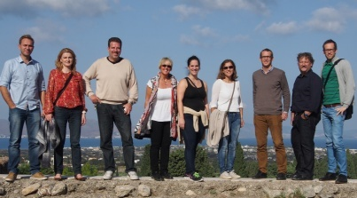
A2 | 10 Nov  2014 | Evaluation of Transnational Project Meeting and Final Report for M1
A2 | Nov to Dec  2014 | Preparation for the pupil exchange in Austria  - students helped by teachers do research as preparation for the first visit  - preparing presentations of each school, town, region and country  - each country gathers information about the social networks  - preparing a visual presentation of each country's statistics
 | 25 Nov | Reporter for regional paper ” ttELA” makes interview with Fridagymnasiet’s project coordinator as well as Teachers and Students participating in the C1-C2 meeting in Austria | 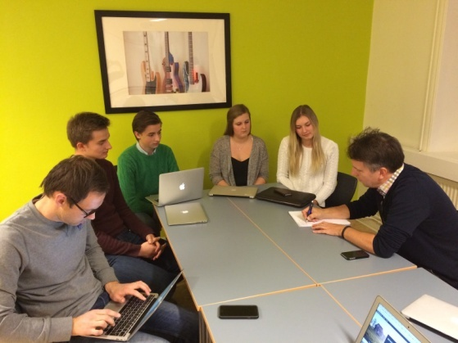
 | Nov-Dec | Filling out the survey before and after Austria in two years at two compulsory schools in the region and at the Fridagymnasiet.
 | 1 and 3 Dec | Students do last research work to complement the over all picture. Research locally at school. Talk in class groups about addiction in an Internet use context in order to prepare more information about current issues among Swedish students for the meeting in Austria.

 | 2 Dec | Article in the regional paper about the SIFA project and the upcoming meeting in Austria | http://www.sifaplus.eu/en/addictions/articles/item/129-the-swedish-team-going-to-austria-appears-in-the-local-newspaper
A2 | December | Students’ working on their presentation about Sweden at the C1-C2 meeting in Austria | http://www.sifaplus.eu/en/addictions/presentations/item/128-swedish-presentation-in-austria
C1 C2  Austria | Sunday 7- Saturday 13 December 2014 | First pupil exchange in Austria:  Matters concerning Internet Addictions:  - excessive surfing  - Social networks (excessive use)  - Online gambling  - Online gaming (excessive use or excessively violent games)  Activities such as:  - Presentations of schools during assembly  - Presentations of students and teachers participating in the meeting  - Statistics concerning Internet Addictions presented by partners  - Discussion comparing the phenomenon in the countries of the project  - Discussion concerning policies that could help reduce the problems encountered  - Searching for solutions to reduce the problems (workshop)  - Making decisions about activities following-up the meeting (workshop to prepare material)  - Making decisions about results of the meetings and material posted on the SIFA site  - Activities in order to know the culture of the country where the meeting is held  - Assessment of meeting (questionnaires)
 |  | Students travelling:  Elin Andersson, Carl Österbrand  Malin Hoffman, Per Isberg  Teachers:  Fabian Helbig, Fredrik Lidén | Student and teacher blog during the meeting in Austria  https://sifafridagymnasiet.wordpress.com/2014/12/08/nu-ar-vi-framme-och-arbetet-borjar/
A2 | December | Students’ presentation about Sweden at the meeting | http://www.sifaplus.eu/en/addictions/presentations/item/128-swedish-presentation-in-austria

A4 SWEDEN | December 2014 to April 2015 | Dissemination for Austria
 | 16 Dec | School project coordinator inform the regional heads at Frida Utbildning (Frida Education) more in-depth about the activities so far and the outcome of the project meeting in Austria.
 | 20 Jan | Information to parents about the SIFA project activities at Fridagymnasiet so far, about the results and activities in Austria and about the next project steps, the meeting in Norway and the planned project activities during the April meeting when Fridagymnasiet is hosting.
A5 | February - mid April 2015 | Follow up teaching and learning activities for Austria  Students at the Fridagymnasiet involved in 6 week project about addiction and the dangers of excessive use of the internet for games and gambling. | http://www.dataspelsmissbruk.se/
A2 | January  March  April | Questionnaires filled out before and after each activity  Dec and Jan- Austria  March - Evaluation and preparation for next project activities among staff and students.  April - After handing out and working with the result of the meeting: “Addiction folder from Austria”
A2 | December  2014 to  February 2015 | Preparation for the pupil exchange in Norway  - students helped by teachers do research as preparation for the first visit  - preparing presentations of each school, town, region and country  - each country gathers information about the social networks  - preparing a visual presentation of each country's statistics
A2 | 9 Jan | First preparation meeting after the Christmas holidays for staff and students going to Norway. Planning of when and how to carry out the surveys before the meeting since there is a one week holiday taking place just before the meeting begins.

A2 | 14 Jan | Students’ research work to complement the over all health picture. Which measures are taken by the authorities in Sweden, guidelines form the Board of Education etc.
A2, A6 | 20150119 | SIFA general presentation to compulsory school students and survey before the C3-C4 Activities in Norway
A5 | 20150123 | SIFA presentation for year 2 students about the work done and results from the C1-C2 Austria activities.
A5 | 20150126 | SIFA presentation for year 1 and 3 students about the work done and results from the C1-C2 Austria activities.
A3, A6 | 20150130 | Preparatory meeting for the students and teachers going to the C3-C4 meeting in Norway  Students travelling:  Oscar Eriksson, Linnéa Sundén, Ellinore Lindström, Anna Kristiansson  Teachers: Rickard Janveden, Fabian Helbig

 |  | Students’ blog example | https://sifafridagymnasiet.wordpress.com/2015/02/11/tisdag-i-os/
 |  | Swedish Teachers’ presentation for Norwegian ICT teachers during the meeting in Os. | http://www.sifaplus.eu/en/health/presentations/item/134-webpage-sifaplus-eu-and-the-swedish-way-of-using-ict
A4 All | Feb to June | Dissemination for Norway
 | 19 February | School project coordinator informs the regional heads at Frida Utbildning (Frida Education) more in-depth about the SIFA project activities on the health theme leading up to the meeting in Norway as well as the outcomes of that project meeting .
 | 23 February | The students who travelled to Norway sent an article about the SIFA meeting for publication in the regional paper ttELA. However, the article was never published as the paper said there was no room at the moment! | 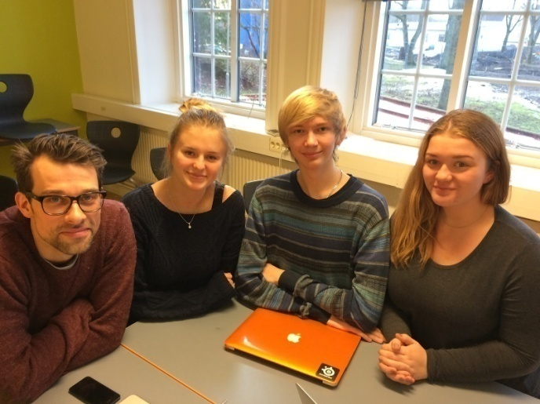
A6 | 3 MARCH | Survey after the C3-C4 meeting in Norway
A4 | 25 MARCH | Presentation of the research results of the survey after the C3-C4 meeting in Norway

A4 | 12 March | The students made the same presentation and dissemination activity for pupils in year 8 and 9 (14-16 years old) at the Frida primary school in Vänersborg
A2 | February  2015 to  April 2015 | Preparation for the pupil exchange in Sweden  - students helped by teachers do research as preparation for the first visit  - preparing presentations of each school, town, region and country  - each country gathers information about the social networks  - preparing a visual presentation of each country's statistics
A2 | 18 Feb and 10 April | Swedish organiser in contact with Erasmus+ KA 2 desk clerk Jessica Hintze at Swedish NA in order to prepare for either a visit to Vänersborg during the meeting or a visit to the NA for the visiting teachers whilst in Stockholm.
A5 | March | Workshop during class hours on report about security on the Internet. How common is it to feel badly treated? Do the students have confidence in the judiciary? How should the network companies act? | http://www.mucf.se/publikationer/natkrankningar-hur-vanligt-ar-det

A2 | 6 March | Planning meeting with Innovatum Science Park in Trollhättan about the tailor made activity and lecture day for students and teachers during the Swedish project meeting in Vänersborg. School coordinator Karin Helmerson and Fabian Helbig (Fridagymnasiet) met with Lillemor Lindberg, Holly Xiao, Jerry Alrup and Pär Mauritzon (Innovatum Science Park) http://www.innovatum.se/skola/pedagogiska-program/pedagogiska-program-gymnasietvuxna/
A2 | 9, 12, 25 and 30 March | Staff planning meetings at Fridagymnasiet to prepare for the SIFA project meeting. The necessary preparations and presentations to be done before hand and the activities and group workshops to be carried out during the project meeting.  The school coordinator made necessary arrangements for the Stockholm part of the meeting, organising pedagogical guides at the Museum of Technology and the Vasa Museum as well as contacting the NA in order to set up a time for meeting with the visiting teachers. | http://www.sifaplus.eu/en/security/activities/item/292-preparation-before-the-meeting-in-sweden
A2 | 27 March | Meeting with Swedish host students to prepare for the C5-C6 meeting at Fridagymnasiet
A2 | 9 April | Follow up preparation meeting between Fridagymnasiet coordinator Karin Helmerson and the Innovatum Science Park International project coordinator Mrs. Lillemor Lindberg.
C5 C6  Sweden | Sunday 12- Saturday 18 April 2015 | Third pupil exchange in Sweden:  Matters concerning Security on the Internet:  During the meeting in Sweden, matters concerning security related to Internet and new media were dealt with. The students' work on internet security was divided into four sub categories. Security for:  - Government and Institutions  - Banks and Payments  - Companies  - Private persons
A3 | April 2015 to  June 2015 | Follow up activities for Sweden.  - presenting the information about the visit results to the local community  - Each country’s group of students who participated at the last meeting, on their return will organize a short course (will produce activity sheets, will prepare their teaching) in order to act as teachers and to disseminate their experience to their classmates (with the help and supervision of their teachers). The subject of the course will be directly related to the matters discussed during the meeting in Austria, i.e. social networks, dangers and misuses.  There will be an evaluation of the process; questionnaires will be answered both previously and after the activities.
A3 | 18 April | Norwegian students’ evaluation of Swedish meeting | http://www.sifaplus.eu/en/security/articles/item/272-the-norwegian-students-experiences-in-sweden
A3 | 18 April | Polish students’ thoughts on Swedish meeting | http://www.sifaplus.eu/en/security/articles/item/255-logrojec-sweden-memories
A3 | 29 and 30 April | Students and staff informed other students at the Fridagymnasiet about the SIFA project activities so far. By showing the evaluations made by the visiting students (see above), the film trailer about the meeting made by the Polish team and the results of the international project meeting about Security just held at the school the students were able to see they had made an impact. The students were also informed on the upcoming workshops on the Security topics, using the result material from the meeting. | http://www.sifaplus.eu/en/security/articles/item/288-dissemination-activity-at-fridagymnasiet-student-information  https://www.youtube.com/watch?v=zzUrhi4WEfU (Polish trailer about meeting in Sweden)

A4 | 15 April 2015 | Parents’ meeting 1 and lecture about some of the dangers with excessive internet use as well as more information on the health and security aspect. Information about the SIFA activities so far and the ongoing project meeting about Security. | http://www.sifaplus.eu/en/security/articles/item/287-dissemination-activity-at-fridagymnasiet-parents-meetings
A4 | 21 April 2015 | Parents’ meeting 2 and lecture about some of the dangers with excessive internet use as well as more information on the health and security aspect. information about the SIFA activities so far and the international project meeting about Security just held. | 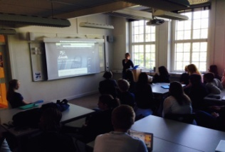
A4 | 22 Aprill | Since the regional newspaper “ttELA” did not cover the activities during the meeting at the Fridagymnasiet, teachers and students wrote a report about the meeting and sent it to the paper. However, the article was not published.
A6 | 18 May  + 1 June | SIFA survey work after Sweden meeting
A2, A3 | 20 May | Meeting with the host students during the C5-C6 meeting in Sweden to work on the presentations of the results of the learning activity.
A5 | 27 May | Presentation to all students about the outcomes of the C5-C6 meeting 4 Workshops at Fridagymnasiet.
A1 | May-June | The SIFA team at Fridagymnasiet work on the shared progress report and the Transnational meeting M2 in Poland.
A4 | 8 June | School project coordinator inform the regional heads at Frida Utbildning (Frida Education) more in-depth about the outcome of the project meeting hosted by Fridagymnasiet as well as the evaluation results.
A6 | 8 and 9 June | SIFA Celebrations and Certificate awards to students of year 2 (8th June) and 1 (9th June). Evaluation of the SIFA project year as well as a brain storm workshop to collect good ideas from the students about a good kick-off activity for the project in the autumn. | http://www.sifaplus.eu/en/security/articles/item/290-evaluation-and-celebration-of-the-sifa-project-so-far  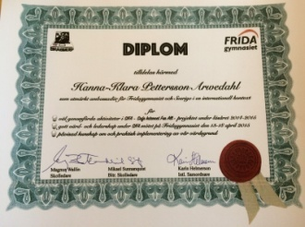  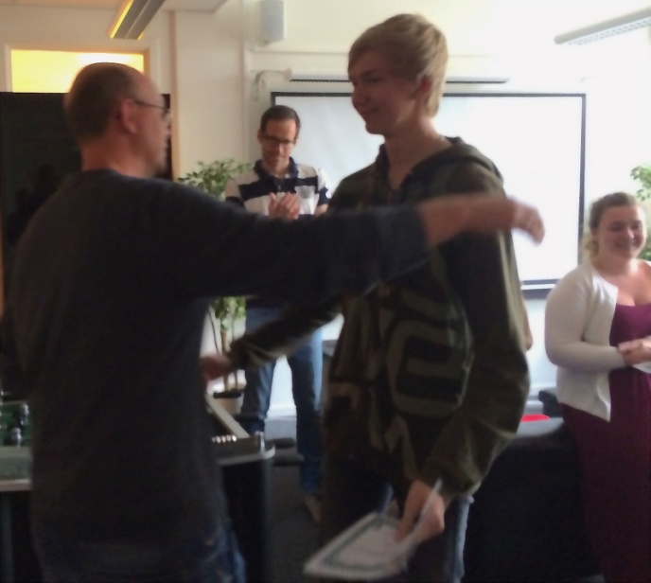  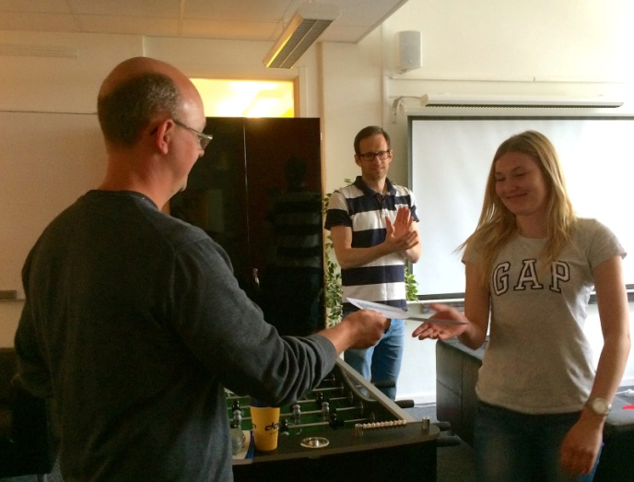
M2 Poland | 11-15 June 2015 | 2nd Transnational Project Meeting in Poland  Katharina Fahrenheim and Åsa Segelod represent the Fridagymnasiet SIFA team at the meeting at the partner school in Grojec, Poland.
A6 Poland | 15 June 2015 | Evaluation of Transnational Project Meeting Poland  leading to Final Report for M2
A4,A6 | 16 June | The very last day of the spring term for teachers in Sweden - Katharina Fahrenheim and Åsa Segelod inform the teachers at the Fridagymnasiet about the activities carried out, the SWOT analysis and discussions during the transnational meeting in Poland. The SIFA teacher team made an evaluation about how to improve the efficiency of handling the questionnaire work as well as disseminating the project activities to the regional paper that has proved not so willing to publish material about the project.
A6 | Mid-End June | Continued work on the project progress report for Sweden as well as the online report for the Swedish National Agency.
A5 | 20150902 | SIFA DAY presentation about the project progress so far including SIFA Parent presentation in the evening
A2 | 20150910 | Preparation with students for the C7-C8 SIFA Tasks and Activities on ethics in Greece
A2 | 20150924 | Preparation with students for the C7-C8 SIFA Tasks and Activities on ethics in Greece

C7-C8 | 27 SEPT-2 OCT  2015 | During the meeting in Greece, matters of Ethics related to internet use were mostly dealt with, such as plagiarism, copyrights, rights and responsibilities, ways of acting, etc.  Participating students: Lovisa Wikmark, Evelina Pettersson, Josefin Viljakainen, Adam Strandberg-Hassellind  Participating Teachers: Katharina Fahrenheim, Mikael Sunnanquist
A6 | 20151005 | Evaluation meeting with the students who participated in the C7-C8 meeting
A5 | 20161021 | Presentation for all year 2 students about about the outcomes of the C7-C8 Activities in Greece. | http://www.sifaplus.eu/en/ethics/gallery/item/377-ethics-swedish-presentation-of-sifa-meeting-in-kos
A5 | 20151019-20151023 | After the Learning activity in Greece, the participating students visited the Fridaskolan compulsory schools in Vänersborg, Trollhättan and Uddevalla to inform and implement their knowledge.
A5 | 20151104 | Presentation for all year 1 and 3 students about about the outcomes of the C7-C8 Activities in Greece.
A4 | 20151103-20151105 | In Stockholm with LIN Education to take part in the the SETT - ”Scandinavian Educational Technology Transformation” - expo, where Education technology solutions and inventions of the future are presented. Meeting politicians for dialogues concerning relevant topics.  Pictures with:  Top -the minister of Education, Mr Jan Björklund  Middle Sweden’s Prime Minister Stefan Löfvén  Bottom - Sweden’s Former Prime Minister Mr Fredrik Reinfeldt  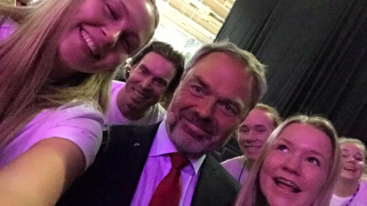  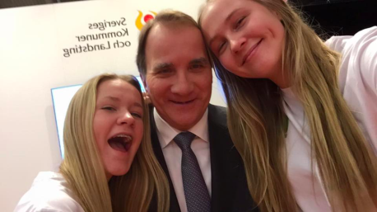  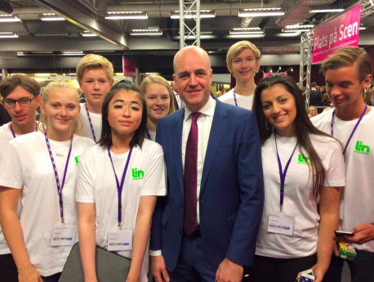  http://settdagarna.se/  http://lineducation.se/
A4, A5 | 20151214 | Presentation on C7-C8 Greece activities for the 8th and 9th year pupils at the compulsory schools in Vänersborg and Trollhättan
A6 | 20160121 | Post C7-C8 survey work
A2 | 20160302 | SIFA information and documentation meeting for all staff - what has been done so far, what is left to do
A2 | 20160309 | Preparatory meeting with coordinator, teachers and students for SIFA C9-C10 in Poland
C9-C10 | 23-30 April | Meeting in Poland on Internet Safety  Participating students: Wilma Johnte, Hanna-Klara Petterson, Brittan Kaymaz, Filippa Brodén  Participating Teachers: Erik Alvin, Robert Tuveson
A5 | 20160511 | Presentation for all year 2 students about about the outcomes of the C9-C10 Activities in Poland.
A5 | 20160530 | Presentation for all year 1 students about about the outcomes of the C9-C10 Activities in Poland.
A5 | 20160601 | Presentation for all year 3 students about about the outcomes of the C9-C10 Activities in Poland.
A9 | 160601 | SIFA Evaluation meeting in school with all students.  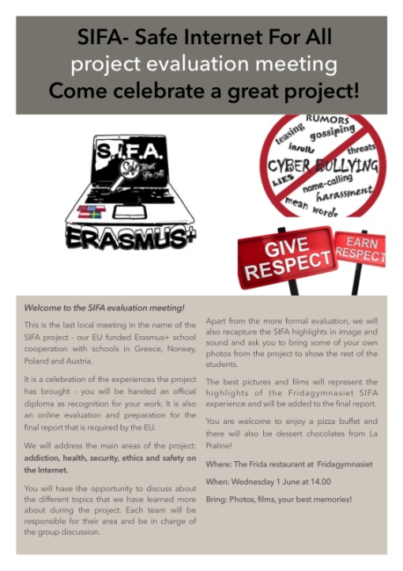  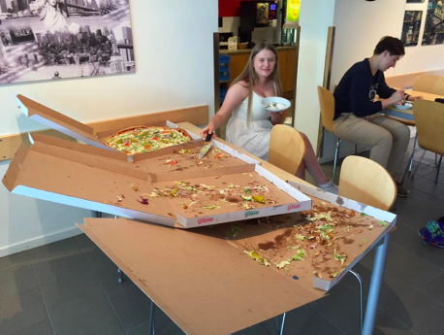
A1 | 160602+160614 | Report and documentation meeting for mobility tool+, with International coordinator, teachers and principals at Fridagymnasiet.
A1 | 160614 | Preparation for the M3 meeting in Austria, the International coordinator, the principals and the Swedish teacher participating in the meeting.

Licence Άδεια
Our SIFA project has officially ended. Yet, we relevant follow up activities will continue for at least two more years and especially dissemination activities for the results and products that have been created. We would like to thank all students, teachers, parents, organisations and scientists/guests that participated in some way and helped us during the project implementation.
The project is now under evaluation by the Greek National Agency and the products presented might be submitted to some change. Yet, meanwhile, we would like to present the Final Products of this 2 year collaboration, for which we are proud of and have been produced by all participants in SIFA. If they are submitted to changes, the current version will be updated by the revised versions.
Anybody can use the material produced during SIFA implementation, as long as they mention the Erasmus+ Project SIFA and that the products have been created by EU Erasmus+ funding.

The attachments (SIFA products) are licensed under a Creative Commons Attribution 4.0 International License and have been created during the implementation of the Erasmus+ Safe Internet For All (2014‐1‐EL01‐KA201‐001294) project.
Τα προϊόντα που ακολουθούν έχουν άδεια Creative Commons Αναφορά Δημιουργού - Παρόμοια Διανομή 4.0 Διεθνές και έχουν δημιουργηθεί στο πλαίσιο του προγράμματος Erasmus+ Safe Internet For All (Ασφαλές Διαδίκτυο για όλους - Σύμπραξη αποκλειστικά μεταξύ σχολείων με κωδικό 2014‐1‐EL01‐KA201‐001294)

