During the meeting in Greece, matters of Ethics related to internet use were mostly dealt with, such as plagiarism, copyrights, rights and responsibilities, ways of acting, etc.
The program is shown in this link: http://www.sifaplus.eu/en/item/13-4th-short-term-exchanges-of-groups-of-pupils
More details are shown in the extra file.
The following products were produced during the meeting:
Final product for meeting in Greece (kahoot game)
http://www.sifaplus.eu/en/ethics/results/item/332-final-product-about-ethics-kahoot-game
Final product for meeting in Greece (apps inventor quiz/game)
http://www.sifaplus.eu/en/ethics/results/item/333-final-product-about-ethics-apps-inventor-quiz
Creation of video about the meeting http://www.sifaplus.eu/en/ethics/gallery/item/339-video-about-safe-internet-for-all-meeting-in-greece-about-ethics
Creation of video about the meeting http://www.sifaplus.eu/en/ethics/gallery/item/340-video-about-safe-internet-for-all-meeting-in-greece-about-ethics-2nd
Extra File:
Information and proof of activities from Progress Report file of Greece

C7 C8  Greece | Sunday 27 September 2015 - Saturday 2 October 2015 | Fourth pupil exchange in Greece:  Matters concerning Ethics:  · Copyright  · Plagiarism  · Legal issues  · Responsibilities and Rights  Activities such as:  - Presentations of students and teachers participating in the meeting  - Statistics concerning the matters of the meeting presented by partners  - Discussion comparing the phenomena in the countries of the project  - Discussion concerning policies that could help reduce the problems encountered  - Searching for solutions to reduce the problems (workshop)  - Making decisions about activities following-up the meeting (workshop to prepare material)  - Making decisions about results of the meetings and material posted on the SIFA site  - Activities in order to know the culture of the country where the meeting is held  - Assessment of meeting (questionnaires)  Participants:  Teachers  Greece Giorgos Errikos Chlapanis  Greece Athina Minaidi  Greece Mary Loumani  Greece Sophia Diakidou  Greece Rodia Vasiliadou  Greece Ilias Diamantis  Greece Daisy Perezou  Greece Minas Chatziantoniou  Greece Maria Koutsi  Poland Pawel Posnik  Poland Ada Posnik  Poland Iwona Kwapisz  Poland Anna Mocarska-Karwan  Norway Tone Hadler Olsen  Norway Mona Stigen  Sweden Mikael Sunnanqvist  Sweden Katharina Fahrenheim  Austria Klaudia Panstingl  Austria Helga Geyrecker  Students  Greece Charalampos (Charis) Fratzakis  Greece Christina Foutsa  Greece Theodoros (Akis) Kalogerakis  Greece Gioulide Pasha  Greece Maria Ioannidou  Greece Pavlos Nikolaou  Greece Odysseas Chlapanis  Greece Leonidas Segraidos  Greece Antonis Pyliotis  Greece Kalotina Korfia  Greece Georgia Siatore  Greece Katerina Geraskli  Greece Anthi Metaxa  Greece Orestis Rapesis  Greece Katerina Antonia Kontoverou  Poland Agnieszka Mazur  Poland Magdalena Andrychowicz  Poland Pawel Gorecki  Poland Wiktoria Gryczko  Poland Kamil Posnik  Norway Stine Engelsen Tveit  Norway Maren Heimro Berg  Norway Henrik Vågen  Norway Leon Alexander Lorentzen  Sweden Adam Strandberg Hassellind  Sweden Lovisa Wikmark  Sweden Evelina Pettersson  Sweden Josefine Viljakainen  Austria Stefan Musil  Austria Reinhard Luger  Austria Lydia Baumgartner  Austria Sandra Dallinger
C7 C8  Greece | Sunday 27/9/15 | Task work dinner | Discussion about schedule and activities with teachers
C7 C8  Greece | Monday 28/9/15 | Task Presentation of schools  https://drive.google.com/folderview?id=0B6i1EVWz6r7mTEUwT1JEc01Kc2M&usp=sharing | 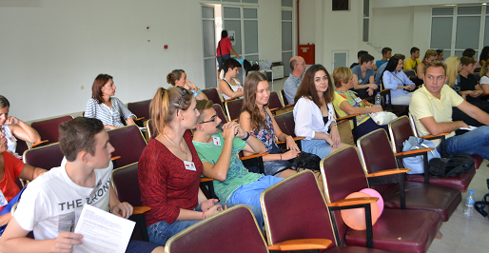
C7 C8  Greece | Monday 28/9/15 | Icebreaking activities for teachers  https://drive.google.com/open?id=0B6i1EVWz6r7mTk05bEphNm9IY3c
C7 C8  Greece | Monday 28/9/15 | Icebreaking activities for students  https://drive.google.com/open?id=0B6i1EVWz6r7mTk05bEphNm9IY3c | 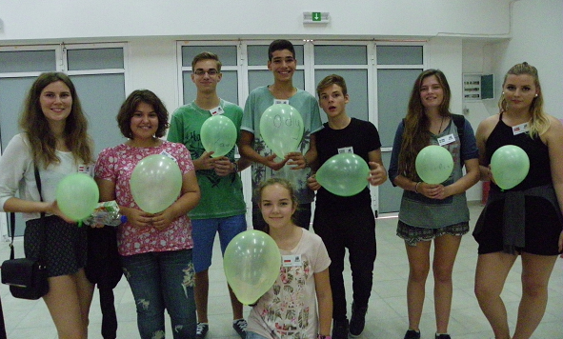
C7 C8  Greece | Monday 28/9/15 | Task Presentation of research results | https://drive.google.com/open?id=0B6i1EVWz6r7mbHR4V2oxSDJKNFE
C7 C8  Greece | Monday 28/9/15 | Workshop students work about research results  Presentation of research results | https://drive.google.com/open?id=0B6i1EVWz6r7mYWp4b0Uzc09hanc  https://drive.google.com/open?id=0B6i1EVWz6r7meFZyM0xlVWQ2S3c
C7 C8  Greece | Monday 28/9/15 | Visit at Municipality | https://drive.google.com/open?id=0B6i1EVWz6r7ma2RWRWlKWU5tblE  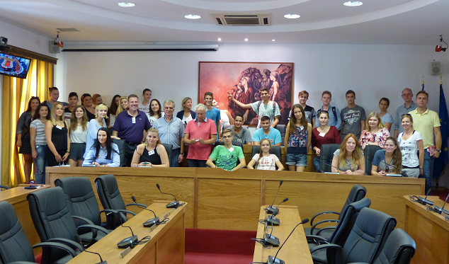
C7 C8  Greece | Monday 28/9/15 | Guided tour at Asklipeion | https://drive.google.com/open?id=0B6i1EVWz6r7mT0pWSEhKY2tQMW8  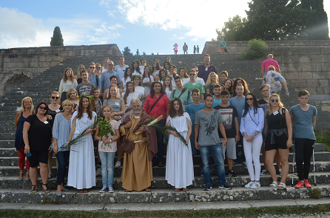
C7 C8  Greece | Tuesday 29/9/15 | Presentation of Creative Commons by Sifis Chatzimichalis (ICT expert) | https://drive.google.com/open?id=0B6i1EVWz6r7mQnV2aW4ta1hzTU0
C7 C8  Greece | Tuesday 29/9/15 | Workshop about Creative Commons, Licences, Copyright, etc. use of www.webwewant.eu | https://drive.google.com/open?id=0B6i1EVWz6r7mMGpOWjRfLUZ1S0E
C7 C8  Greece | Tuesday 29/9/15 | Guided tour Casa Romana and Archaeological walk in town (by Hlapanis Georgios) | https://drive.google.com/open?id=0B6i1EVWz6r7mNFYxYkVHd0Q5M0E
C7 C8  Greece | Tuesday 29/9/15 | Workshop Kahoot activities  https://play.kahoot.it/#/?quizId=3864f024-2f20-4023-bd1e-68d691968f09 | https://drive.google.com/open?id=0B6i1EVWz6r7mS25aME9HODNCYzA  and  https://play.kahoot.it/#/?quizId=2c536432-f76d-4c30-aef3-edff4aee4e40
C7 C8  Greece | Tuesday 29/9/15 | Presentation and Workshop by Aris Louvris (ICT expert, contact person for eSafety in Greece and co author of www.webwewant.eu ) | https://drive.google.com/open?id=0B6i1EVWz6r7mflN0anJaazM4bUd3eTcwSjN0OXA4N01xM1BiUHNOZElQYTJyTDNGYW9PRDQ
C7 C8  Greece | Tuesday 29/9/15 | Leisure activities  https://drive.google.com/open?id=0B6i1EVWz6r7mOTg5b0U0NlZSZWc  https://drive.google.com/open?id=0B6i1EVWz6r7manVDcWQwTFd5bE0 | 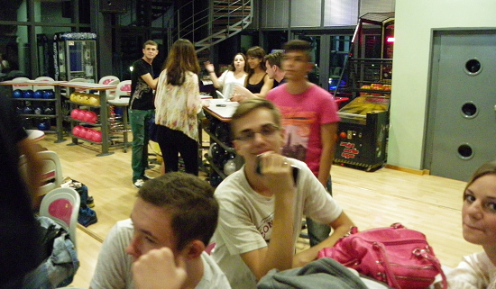
C7 C8  Greece | Wednesday 30/9/15 | Teleconferencing with expert from Greek Police Department fighting electronic crime  https://drive.google.com/open?id=0B6i1EVWz6r7mYjNVYlRwcnVXaHM | 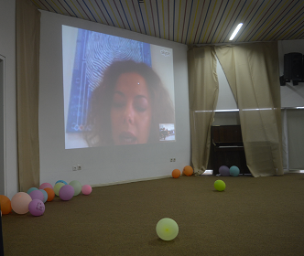
C7 C8  Greece | Wednesday 30/9/15 | Presentation and Workshop with psychologist Maria Drosou  about Cyberbullying and online behaviour and Ethics  https://drive.google.com/open?id=0B6i1EVWz6r7mSUZNU1ZXa21EUWs | 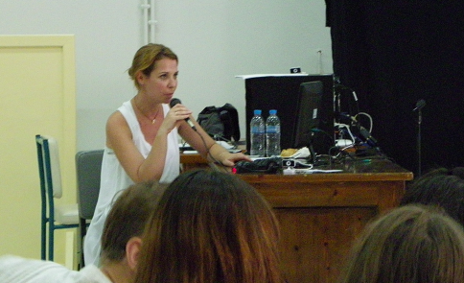
C7 C8  Greece | Wednesday 30/9/15 | Presentation of results from previous workshop  https://drive.google.com/open?id=0B6i1EVWz6r7mNzliQjZjYi1yTVE | 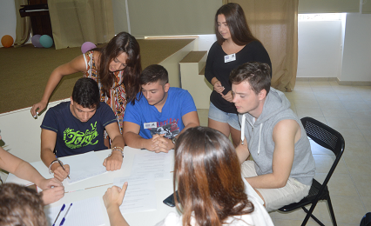
C7 C8  Greece | Wednesday 30/9/15 | Leisure activities  Lunch at school offered by parents  https://drive.google.com/open?id=0B6i1EVWz6r7mbGk4ZG1CWDRzMVE | 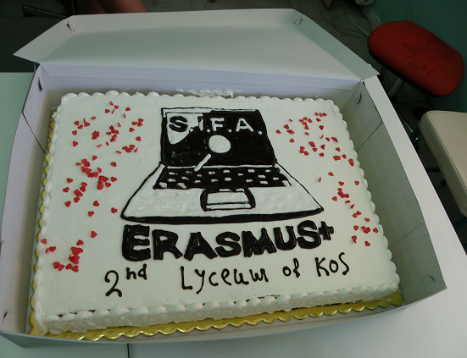
C7 C8  Greece | Wednesday 30/9/15 | Leisure activities  Sports activities at Blue Lagoon Resort  https://drive.google.com/open?id=0B6i1EVWz6r7mbGk4ZG1CWDRzMVE | 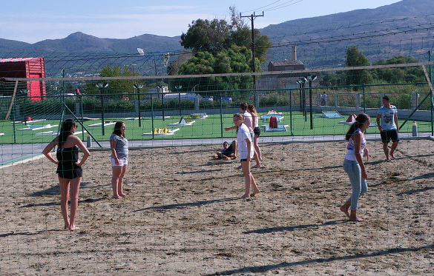
C7 C8  Greece | Thursday 1/10/15 | Trip to the Island of Rhodes  for several activities | 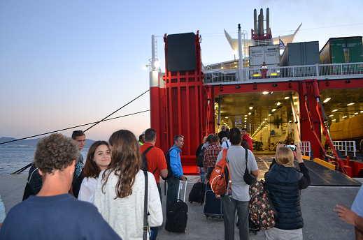
C7 C8  Greece | Thursday 1/10/15 | Presentation of Plagiarism, References, Paraphrasing, APA system by Hlapanis Georgios (on board on the way to Rhodes)  https://drive.google.com/open?id=0B6i1EVWz6r7mRk1LRDQwUjBCclk | 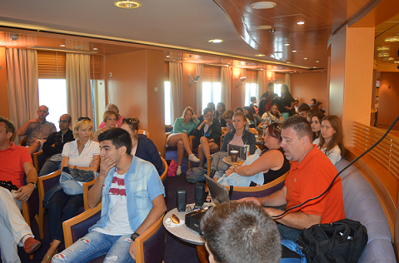
C7 C8  Greece | Thursday 1/10/15 | Workshop related to previous presentation on Plagiarism, References, Paraphrasing, APA system by Hlapanis Georgios and Perezou Daisy (on board on the way to Rhodes)  https://drive.google.com/open?id=0B6i1EVWz6r7mR2tBYzRnNjUyUVU | 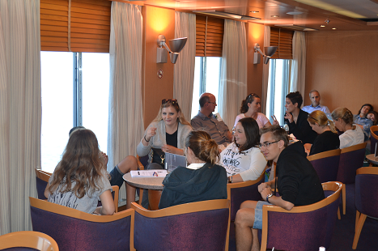
C7 C8  Greece | Thursday 1/10/15 | Workshop in Rhodes at a Vocational upper high school about plagiarism  https://drive.google.com/open?id=0B6i1EVWz6r7mTTc5eGpLbk12RUE | 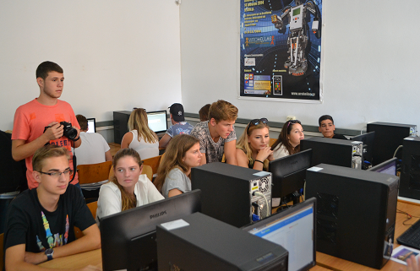
C7 C8  Greece | Thursday 1/10/15 | Visit at University of Aegean Presentation of Plagiarism policy of the University by Dr. Sofos Loisos and Dr. Vratsalis Konstantinos (Dean)  https://drive.google.com/open?id=0B6i1EVWz6r7mT2ptRXBnRzRMR00 | 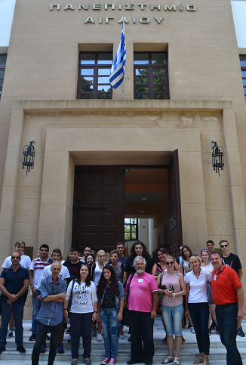
C7 C8  Greece | Thursday 1/10/15 | Cultural activity Throne of Helios  https://drive.google.com/open?id=0B6i1EVWz6r7mT2ptRXBnRzRMR00 | 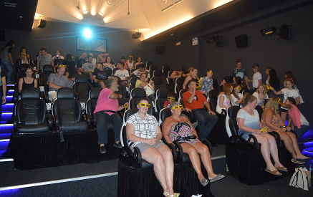
C7 C8  Greece | Thursday 1/10/15 | Cultural activity walk in medieval town  https://drive.google.com/open?id=0B6i1EVWz6r7mT2ptRXBnRzRMR00 | 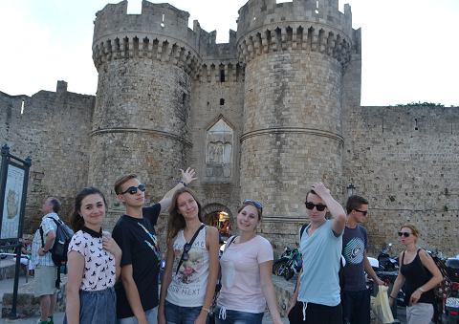
C7 C8  Greece | Friday 2/10/15 | Presentation of matters of ethics regarding online behaviour and post in Social Networks by expert Dr. Kopidakis Giannis | https://drive.google.com/open?id=0B6i1EVWz6r7mS04ySlgwZ3hnZGc
C7 C8  Greece | Friday 2/10/15 | Workshop about matters of ethics regarding online behaviour and post in Social Networks by expert Dr. Kopidakis Giannis | https://drive.google.com/open?id=0B6i1EVWz6r7mZXNEVDVpQmFldTQ
C7 C8  Greece | Friday 2/10/15 | Coordinator from Poland Pawel Posnic presents matters related to next student exchange in Poland (April 2016)  https://drive.google.com/open?id=0B6i1EVWz6r7mckhFRVRQV1d5aEU
C7 C8  Greece | Friday 2/10/15 | Workshop related to the final product of the meeting (a quiz that will be created in apps inventor, kahoot and even scratch) | https://drive.google.com/open?id=0B6i1EVWz6r7mQVZRZThfN0w2a2s
C7 C8  Greece | Friday 2/10/15 | Presentation of final product (the questions chosen by the groups of students for the quiz/game) | https://drive.google.com/open?id=0B6i1EVWz6r7mdHcxRk9GRVRpTG8
C7 C8  Greece | Friday 2/10/15 | Leisure and culture activities  Tour of the Island  Visit at Triantafyllopoulou vines  Blue Lagoon Village  https://drive.google.com/open?id=0B6i1EVWz6r7mMTdud0hwRW5TX2s | 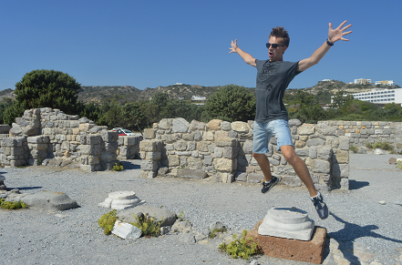
C7 C8  Greece | Saturday 3/10/15 | Evaluation of meeting  https://drive.google.com/open?id=0B6i1EVWz6r7mM2dwWnNwUkpiYzA  Departure of teams | 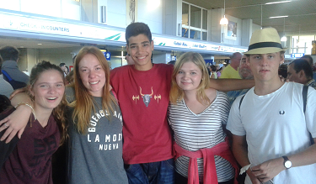

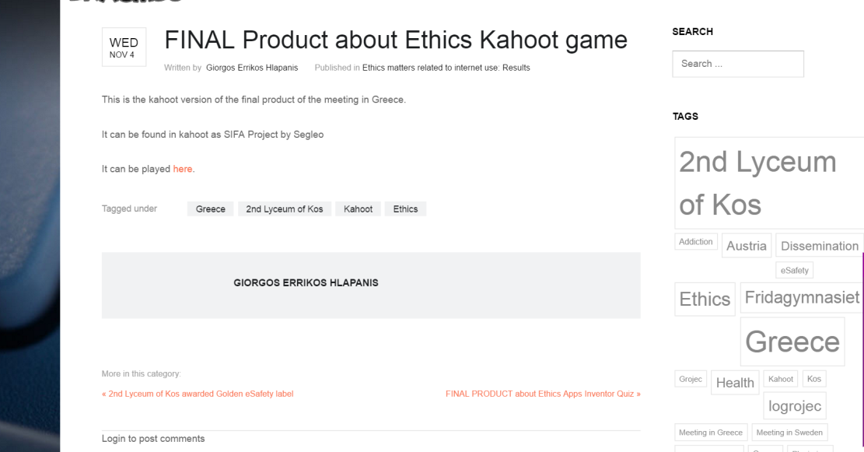
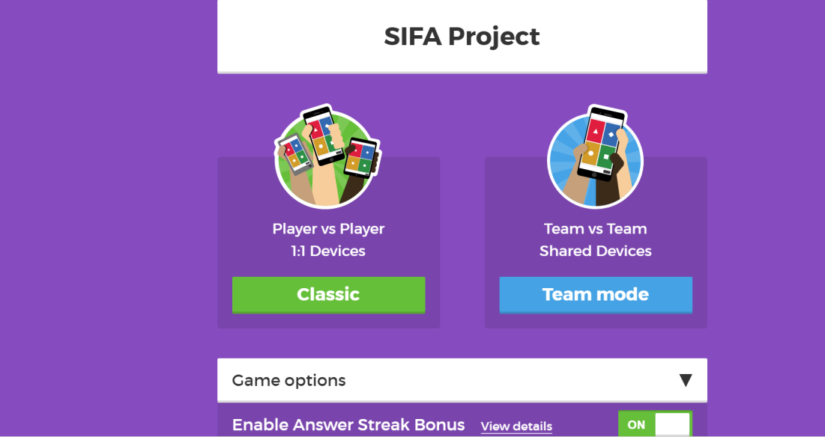
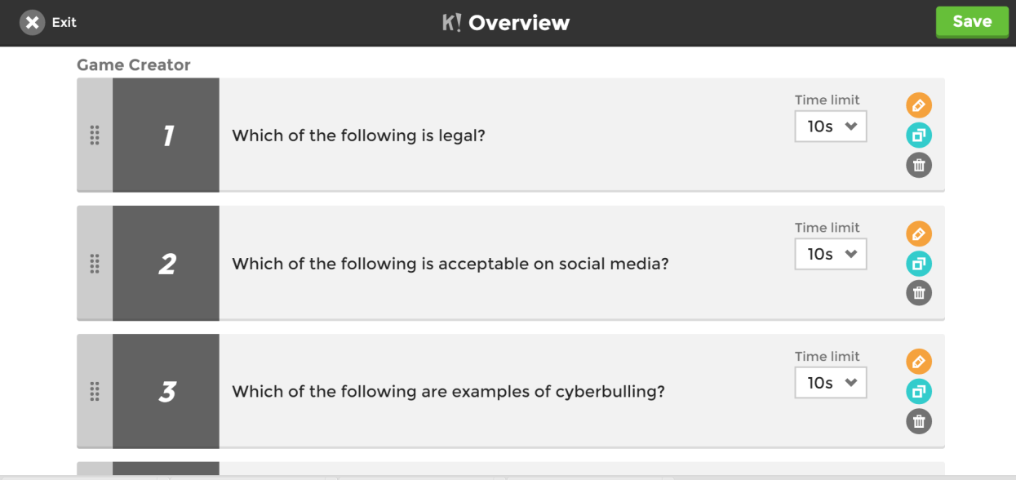
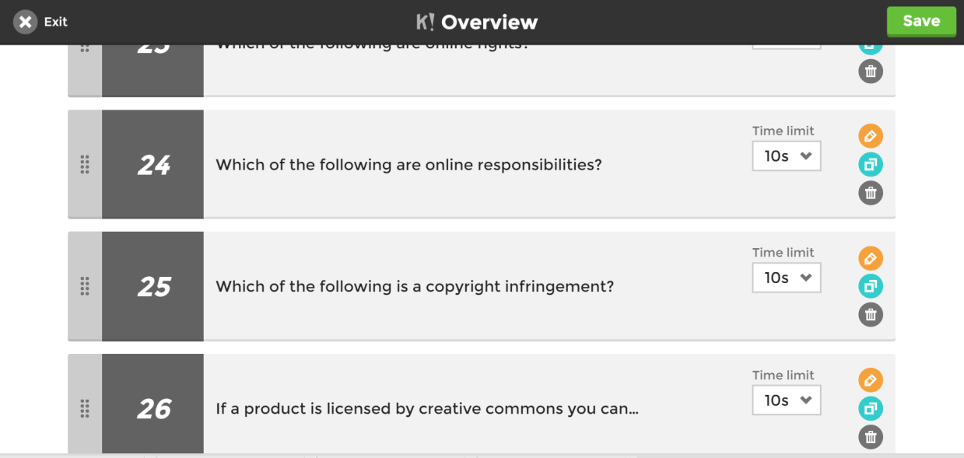
Licence Άδεια
Our SIFA project has officially ended. Yet, we relevant follow up activities will continue for at least two more years and especially dissemination activities for the results and products that have been created. We would like to thank all students, teachers, parents, organisations and scientists/guests that participated in some way and helped us during the project implementation.
The project is now under evaluation by the Greek National Agency and the products presented might be submitted to some change. Yet, meanwhile, we would like to present the Final Products of this 2 year collaboration, for which we are proud of and have been produced by all participants in SIFA. If they are submitted to changes, the current version will be updated by the revised versions.
Anybody can use the material produced during SIFA implementation, as long as they mention the Erasmus+ Project SIFA and that the products have been created by EU Erasmus+ funding.

The attachments (SIFA products) are licensed under a Creative Commons Attribution 4.0 International License and have been created during the implementation of the Erasmus+ Safe Internet For All (2014‐1‐EL01‐KA201‐001294) project.
Τα προϊόντα που ακολουθούν έχουν άδεια Creative Commons Αναφορά Δημιουργού - Παρόμοια Διανομή 4.0 Διεθνές και έχουν δημιουργηθεί στο πλαίσιο του προγράμματος Erasmus+ Safe Internet For All (Ασφαλές Διαδίκτυο για όλους - Σύμπραξη αποκλειστικά μεταξύ σχολείων με κωδικό 2014‐1‐EL01‐KA201‐001294)

