Some interesting screenshots of the site:
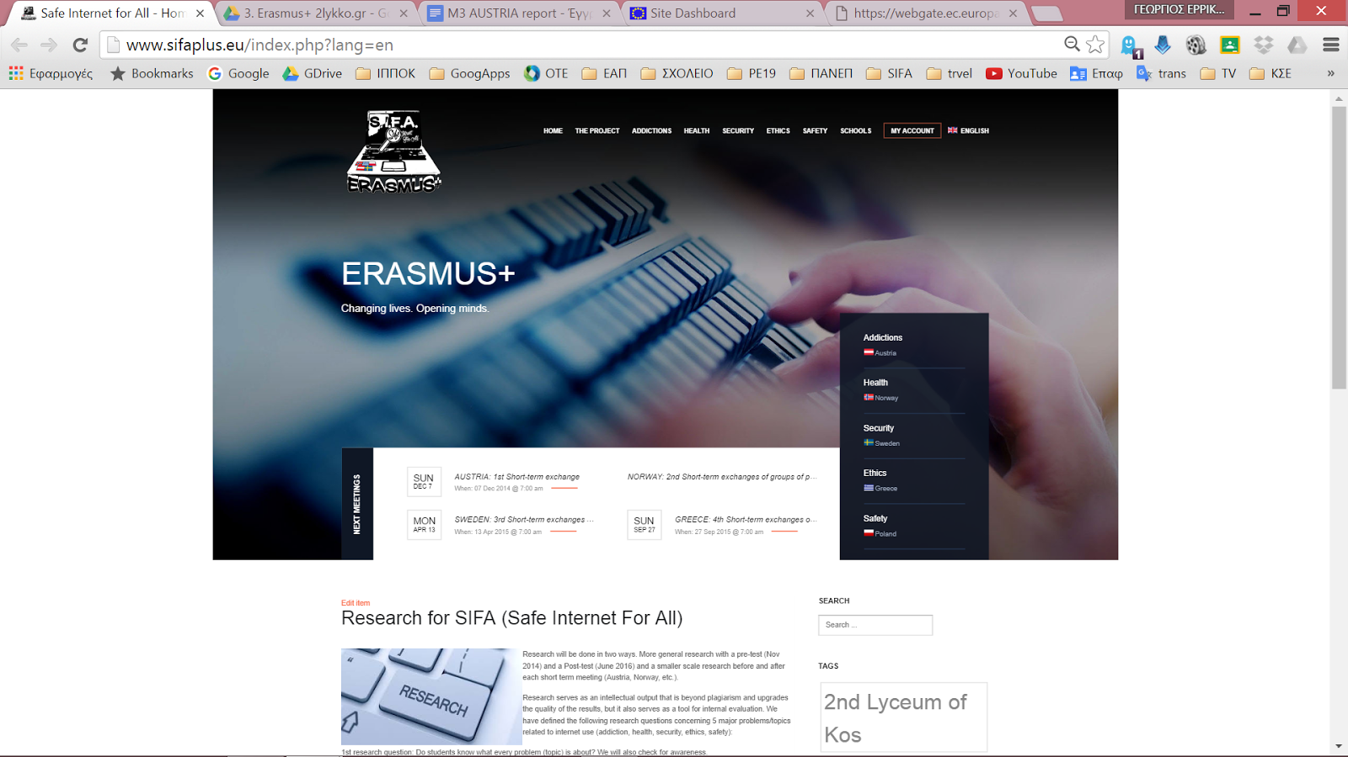
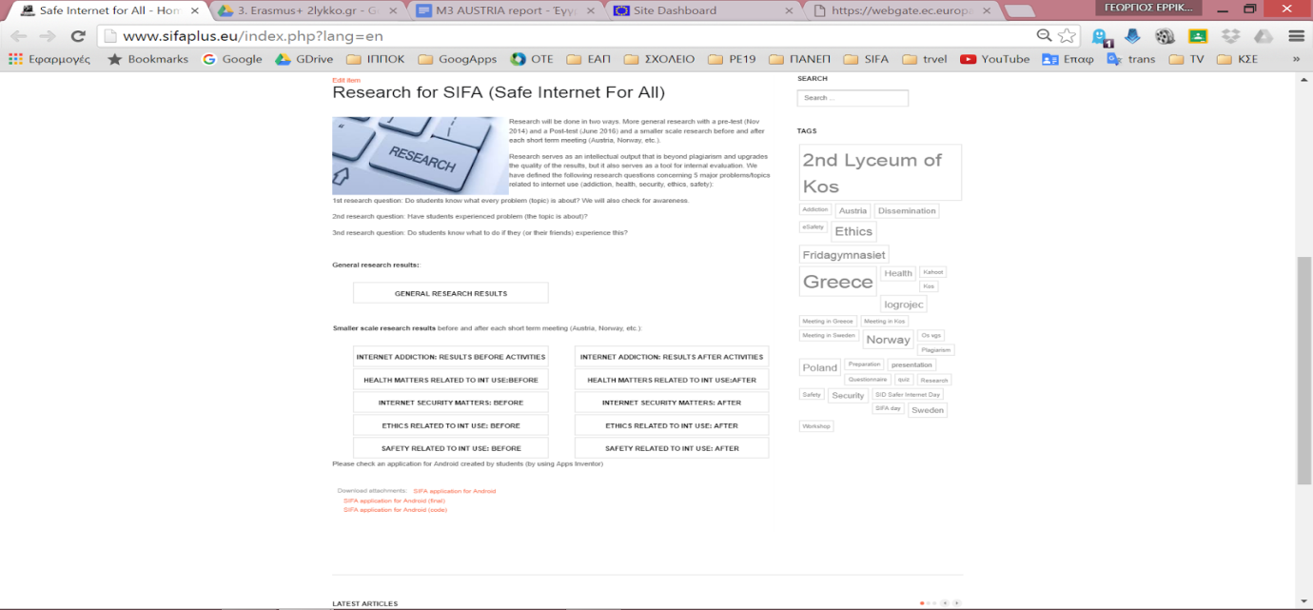
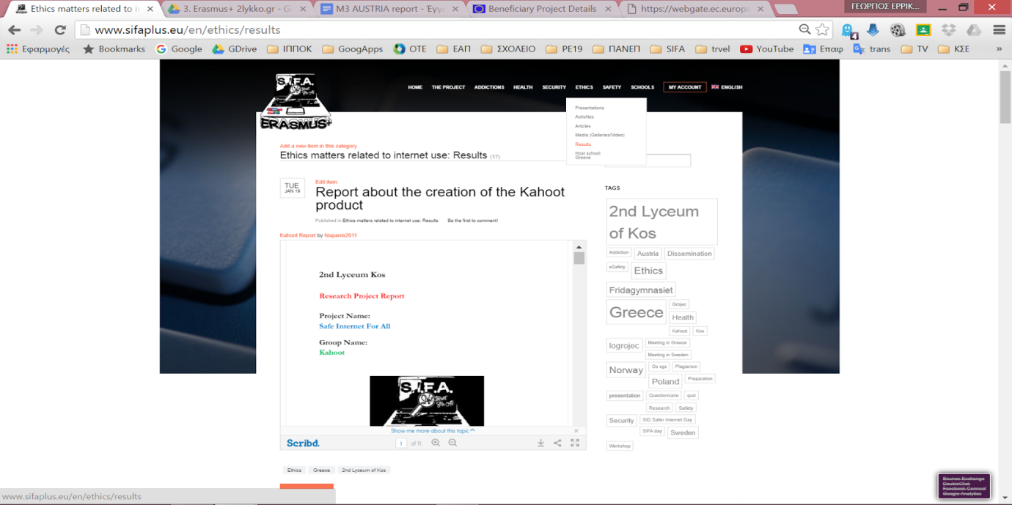

And a google analytics report:
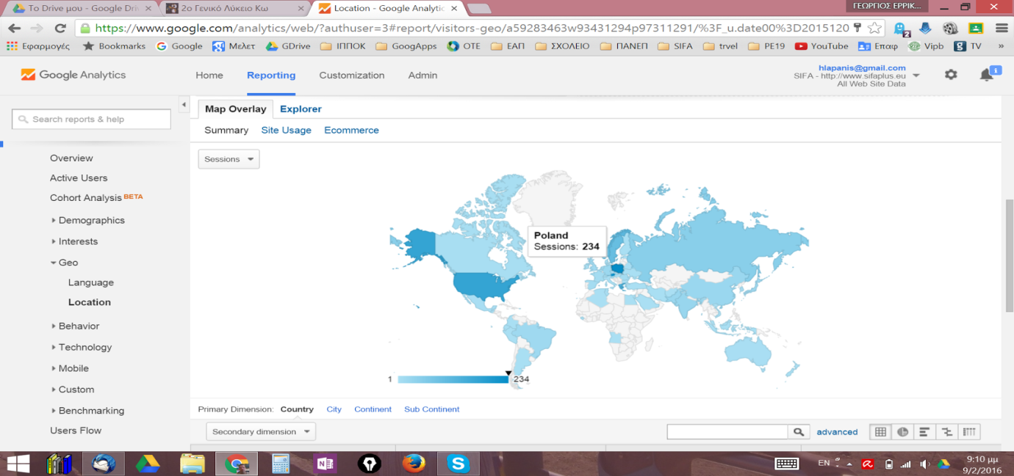

Licence Άδεια
Our SIFA project has officially ended. Yet, we relevant follow up activities will continue for at least two more years and especially dissemination activities for the results and products that have been created. We would like to thank all students, teachers, parents, organisations and scientists/guests that participated in some way and helped us during the project implementation.
The project is now under evaluation by the Greek National Agency and the products presented might be submitted to some change. Yet, meanwhile, we would like to present the Final Products of this 2 year collaboration, for which we are proud of and have been produced by all participants in SIFA. If they are submitted to changes, the current version will be updated by the revised versions.
Anybody can use the material produced during SIFA implementation, as long as they mention the Erasmus+ Project SIFA and that the products have been created by EU Erasmus+ funding.

The attachments (SIFA products) are licensed under a Creative Commons Attribution 4.0 International License and have been created during the implementation of the Erasmus+ Safe Internet For All (2014‐1‐EL01‐KA201‐001294) project.
Τα προϊόντα που ακολουθούν έχουν άδεια Creative Commons Αναφορά Δημιουργού - Παρόμοια Διανομή 4.0 Διεθνές και έχουν δημιουργηθεί στο πλαίσιο του προγράμματος Erasmus+ Safe Internet For All (Ασφαλές Διαδίκτυο για όλους - Σύμπραξη αποκλειστικά μεταξύ σχολείων με κωδικό 2014‐1‐EL01‐KA201‐001294)

