Each partner school has carried out a number of activities to motivate students so that the desired outcome was achieved. During each short-term meeting there were organised workshops to create products referring to the meeting topic. The participants tried to come up with diverse products, e.g. leaflets, movies, multimedia presentations, applications, websites. During the workshops students worked in international groups. The objectives were met. To create a product, students had attended a number of lectures given by specialists in each field. The lectures were given by professors and IT specialists not only at schools but also in prestigious universities and companies. Students also attended lessons at schools. Consequently, the whole school community was actively involved in lessons, presentations and competitions. The workshops were also run by students after each short-term meeting. The following workshops and lessons were carried out in each country respectively:

Austria

A4 Austria | March | Reports of experiences of students about their experiences at SIFA day (24 hours challenge - without internet and mobile phone) used in German lessons. | http://www.sifaplus.eu/de/sucht/artikel/item/132-24-hours-without-internet-and-mobile-phone-follow-up

A5 Austria | March 2015 | Use of folder from meeting in Austria for teaching with focus on topic social media and addiction in 5th form class of HTL

A5  Austria | March 2015 | Workshop health: production of a folder “TEXTNECK” helping to prevent problems from bad posture | http://www.sifaplus.eu/de/gesundheit/artikel/item/240-info-exercises-against-textneck
A8 | March/  April | Use of exercises against bad posture in physical education

A3 Austria | 12 February 2016 | Safe Internet Workshop for secondary school NMS Oberndorf. Workshop organised by our students. | http://www.sz-ybbs.ac.at/~sz-ybbs/news/aktuell/einzelnews/safer-internet-workshop-an-nms-oberndorfmelk-4102/  http://www.nmsoberndorfandermelk.at/galerie/
A3 Austria | 12 April  2016 | Students organise workshop for local female farmers on Internet use | http://www.sz-ybbs.ac.at/~sz-ybbs/news/aktuell/einzelnews/multi-media-kurs-fuer-die-baeuerinnen-4130/  https://www.baeuerinnen-noe.at/?+Multi+Media+Kurs+fuer+die+Baeuerinnen+&id=2500%2C2408844%2C%2C  http://www.ybbs.gv.at/fileadmin/user_upload/aktuelles/Presse/YN_042016_ansicht.pdf

A5 Austria | 2nd June | SIFA DAYS I,  Workshops on sexting, bullying and grooming and legal aspects by organisation JUSY (Jugend Service Ybbstal) | https://www.facebook.com/hak.has.ybbs/posts/514202948772190
A5 Austria | 6th June | SIFA DAYS II  Workshops on sexting, bullying and grooming and legal aspects by organisation JUSY (Jugend Service Ybbstal) | https://www.facebook.com/hak.has.ybbs/posts/514202948772190
A5 Austria | 13th June | SIFA DAYS III  Workshops on sexting, bullying and grooming and legal aspects by organisation JUSY (Jugend Service Ybbstal) | https://www.facebook.com/hak.has.ybbs/posts/514202948772190

Norway

A4  Norway | January 2015 | Students from the exchange in Austria held presentations about the project and work done in Austria in some of the classes at the school.

A3 Norway | 05.05.15 | SIFA-day at school. The students showed the films made in Norway about health. | http://www.sifaplus.eu/en/health/results

A3 Norway | 05/05/15 | SIFA-day at school. The students who went to Sweden presented their final product for their fellow students. | http://www.sifaplus.eu/en/security/articles/item/274-dissemenation-activity-os-norway

A3  Norway | 9.november 2015 | The students presented the trip and what they had learned in their classes.
A3  Norway | 25. January 2016 | The students held a presentation for 50 of the students at the school about their experiences and what they had learned. The students played the Kahoot which was the end result in Greece. | 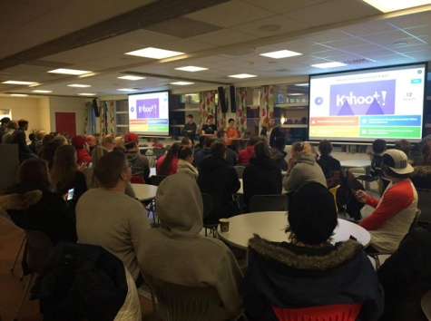

A4 Norway | 18.05.16 | Presentation by the students of webpages made in Poland | http://www.sifaplus.eu/en/safety/articles/item/374-sifa-day-in-norway
A4 Norway | 18.05.16 | Meeting with the anti-bullying representative from our county to tell about the project. | http://www.sifaplus.eu/en/safety/articles/item/374-sifa-day-in-norway

A5 Norway | 18.05.16 | Students worked with some questions regarding the different topics presented by the students who had been in Poland | http://www.sifaplus.eu/en/safety/articles/item/374-sifa-day-in-norway

Sweden
A3 | December 2014 to  April 2015 | Follow up activities for Austria. Dissemination  - presenting the information about the visit results to the local community  - Each country’s group of students who participated at the last meeting, on their return will organize a short course (will produce activity sheets, will prepare their teaching) in order to act as teachers and to disseminate their experience to their classmates (with the help and supervision of their teachers). The subject of the course will be directly related to the matters discussed during the meeting in Austria, i.e. social networks, dangers and misuses.  There will be an evaluation of the process; questionnaires will be answered both previously and after the activities.
A3 | 15 Dec | Student and teachers report after the meeting in Ybbs. Staff discussions about the teacher meeting outcome as well as preparation and planning of the first activities of the project to start the spring term. Fixing the dates for the presentations and disseminations about the Austria meeting in the regional primary schools.
A3 | 19 Jan | General presentation about SIFA as well as some of the the outcomes of the meeting in Austria for the Fridagymnasiet students.  Teachers’ planning meeting to prepare for the upcoming meeting in Norway.
A3,A4, A5 | 6 and 8 May | Students involved in the meeting in Sweden presented the final results to pupils in year 8 and 9 (14-16 years old) at two regional compulsory schools. They had questions for group discussions and workshops with the students in order to spread information about the project and the results of the meeting in Sweden.
A5 | 23 Jan | Discussions in groups about how to prevent addiction to gaming and excessive use of the internet, what means are available from the authorities and at school, how teachers and staff can help in an efficient way, as well as how to give individual help to friends who feel they might be on the verge of getting addicted.
A5 | 14+16 Jan | “Ses offline” - “See you off-line“  Lecture # 1 about online ethics and discussions in smaller groups.  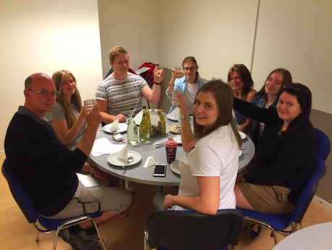 | http://www.mucf.se/publikationer/ses-offline
A5 | end of February - until mid April 2015 | Students at the Fridagymnasiet involved in 6 week project about addiction and the dangers of excessive use of the internet for games and gambling. | http://www.dataspelsmissbruk.se/
A5 | 21 Jan | “Ses offline” - “See you off-line“  Lecture # 2 about online ethics and discussions in smaller groups. | http://www.mucf.se/publikationer/ses-offline
A5, A6 | 23 March | Evaluation and further development work among teachers involved in the student workshops about health and SID activities. Focus on strengthening the awareness of the positive effects of pauses, stretch exercises and ergonomics to prevent aches and muscle problems in connection with using the computer for school work.
A5 | March-  April | - lessons and workshops about finding a healthy balance for Internet use in the student’s daily life. This is essential at the Fridagymnasiet since all information about schedule and school work can be found on the Internet and all assignments and tasks have to be handed in digitally.  Workshop during the students’ class hours 3 times/week | http://internetakuten.com/
A4, A5 | 27 April | Presentation of the Addiction folder from the Austria meeting in workshop groups at Fridagymnasiet with some final ideas in connection to the outcome of the international project meeting about security just held at the Fridagymnasiet. | http://www.sifaplus.eu/en/addictions/results/item/241-folder-how-to-become-addicted-in-seven-days
A5 | 3 Sep | Visiting Karlstad University. Lecture about plagiarism and source criticism with students in second year of upper secondary school.  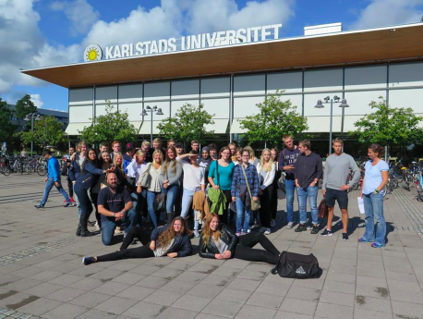 | https://www.kau.se/
A5 | 28 Sep-2 Oct | A whole week of case studies on plagiarism and the criticism of the sources as well as important ethic discussions with all students.  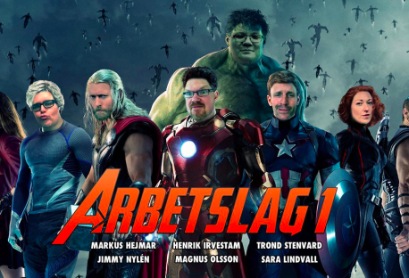 | https://www.hb.se/PageFiles/132916/Urkunds_plagiathandbok.pdf
A4 | 14-15 Oct | Fabian and Henrik, SIFA project teachers at Fridagymnasiet, Lecturing at an expo in Stockholm. Also learning more about new digital education material, digital school books and digital tools.  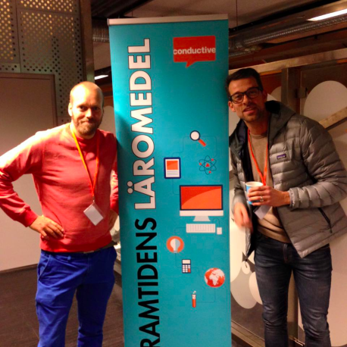 | http://www.framtidenslaromedel.se/stockholm/
A5 | 27 Oct | Staff education evening learning about internet gaming!  ;)  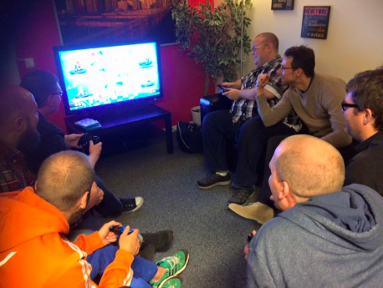
A5 | 17 Dec | “Real Stars” networking against Human trafficking.  Dialogue with students on Values and human trafficking in connection with internet safety and ethics. | http://realstars.eu/
A5 | 2016  28 Jan | History lesson visiting Regionarkivet- the Regional Archive - To understand the importance of criticism of the sources. Case study of the Chernobyl nuclear plant disaster in 1986.  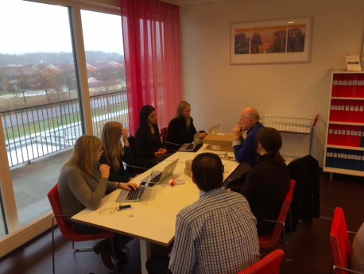 | http://www.regionarkivet.se/  http://www.greenfacts.org/en/chernobyl/
A5 | April-June 2016 | Outdoor prep!  Early morning computer stretch and gymnastics to prepare our bodies for a whole day of studying in front of the computer  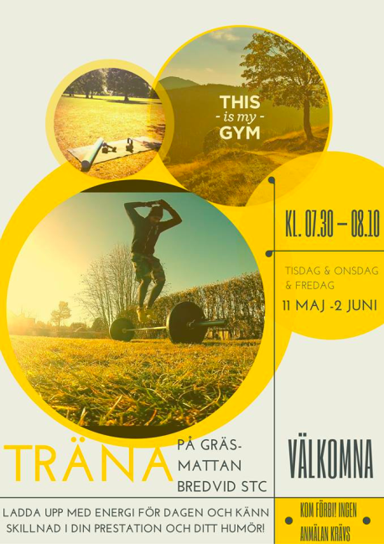  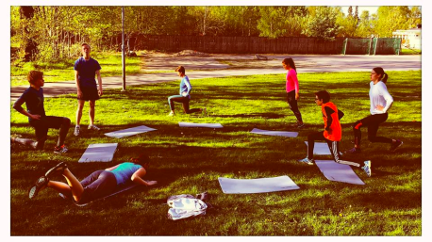 | http://www.sifaplus.eu/en/health/articles/item/284-computer-stretch-exercise
A5 | 2-24 May | Theme work with first year students in History class “Who am I? Who are we?” On the changes their generations have seen compared to older generations. Internet plays a big part in this both directly and indirectly. Reflections, workshops and discussions around technology and the effects and influences of the internet - both good and bad.  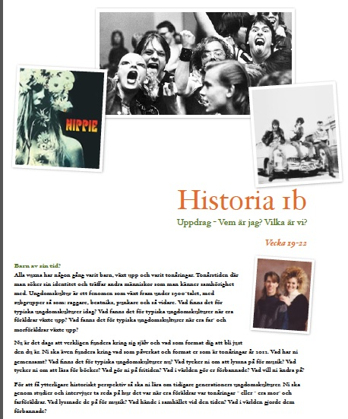

Greece

A5 All | December 2014 to  April 2015 | Further Teaching – Learning activities for Austria
A5  Greece | 27/2/2015 | A group of 3 students of the 2nd Lyceum of Kos (Greece) visited another lower High School of the district (2nd High School of Kos) in order to present to the younger students their work about safety and especially Grooming. They also talked with the students and informed them about the dangers. | http://www.sifaplus.eu/en/safety/articles/item/198-dissemination-activities-students-teaching-other-students-in-greek-schools
A5  Greece | 25/2/2015 | A group of 4 students of the 2nd Lyceum of Kos (Greece) visited another primary school of the district in order to present to the younger students their work about internet addictions, things that were dealt with in Austria. They also talked with the students and informed them about the dangers. | http://www.sifaplus.eu/en/addictions/articles/item/189-dissemination-activities-students-teaching-other-students-in-greek-schools
A5  Greece | 4/2/2015 | Students presenting/talking to other students about Internet Addiction (4th Primary School of Kos). Students from the 2nd Lyceum of Kos have been engaged in presenting problems related to Internet Addiction to other students. | http://www.sifaplus.eu/en/addictions/articles/item/123-students-presenting-talking-to-other-students-about-internet-addiction
A5  Greece | 4/2/2015 | Presentations about Grooming from Students to other Students (1st High School of Kos). Students from the 2nd Lyceum of Kos have been engaged in presenting problems related to Grooming and Ethics to other students. | http://www.sifaplus.eu/en/ethics/articles/item/120-presentations-about-grooming-from-students-to-other-students
A8 All | December 2014 to  April 2015 | Evaluation of Further Teaching – Learning activities for Austria
A8 Greece | 26/6/2015 | Presentation of results in conference in Syros Greece | https://www.scribd.com/doc/270146874/Presentation-in-SYROS-Conference-SIFA-Erasmus-pdf  http://www.authorstream.com/Presentation/hlapanis-2538020-presentation-syros-conference-sifa-erasmus/  http://youtu.be/2PlSsXniCfo
A8 Greece | 23/12/14 | Students presented to students of 2nd Lyceum of Kos work done in Austria and other matters relevant to Safe Internet For All, thus declaring the day an unofficial SIFA day | http://www.sifaplus.eu/en/addictions/articles/item/203-sifa-day-in-greece

A3 Greece | September 2014 to June 2015 | Special lessons in curriculum about projects and especially SIFA erasmus+.  Delivered by Hlapanis Giorgos.  Creation of several projects by students. | Download application  SIFA application for Android  http://www.google.com/url?q=http%3A%2F%2Fwww.sifaplus.eu%2Fen%2Fitem%2Fdownload%2F31_6556fdd2e48cf052c8f42aa24d87a85a&sa=D&sntz=1&usg=AFQjCNFYQuM21-tbuPoi1n1qDxBgR1cTEw

A4 All | February 2015 to  June 2015 | Dissemination for Norway
A4 Greece | 17/3/2015 | Presentation of activities held in Norway to students of 2nd Lyceum of Kos. | http://www.sifaplus.eu/en/health/gallery/item/231-meeting-in-norway
A4 Greece | 20/2/2015 | On Friday 20 February the Greek team who visited Os in Norway presented highlights of the meeting in Norway.The teachers of 2nd Lyceum of Kos were informed about the journey, the activities and the workshops of the program, accommodation conditions, the partners’ schools, the educational system of Norway, how ICT is integrated in teaching in Norwegian schools and last but not least the results and the conclusions of the meeting | http://www.sifaplus.eu/en/health/articles/item/183-dissemination-activities-norway-meeting-2nd-lyceum-of-kos
A4 Greece | 26/2/2015 | Presentation of results in conference in Heraklion Greece | https://drive.google.com/file/d/0B6i1EVWz6r7mR2JjdW1Vc3ZmRU0/view?usp=sharing  https://drive.google.com/file/d/0B6i1EVWz6r7mOXFHRG9scHN2ZDQ/view?usp=sharing  https://docs.google.com/presentation/d/1MBJ_FnCLvvaX1eZyIbmHOObXrD0lDeWl0CKCU5q_T3E/edit?usp=sharing  http://www.sifaplus.eu/en/health/results/item/283-presentation-of-sifa-results-in-conference-in-heraklion-greece  https://www.youtube.com/watch?v=Q7pAmFMGKwY  https://www.youtube.com/watch?v=Q7pAmFMGKwY

A5 All | December 2014 to  April 2015 | Further Teaching – Learning activities for Austria
A5  Greece | 27/2/2015 | A group of 3 students of the 2nd Lyceum of Kos (Greece) visited another lower High School of the district (2nd High School of Kos) in order to present to the younger students their work about safety and especially Grooming. They also talked with the students and informed them about the dangers. | http://www.sifaplus.eu/en/safety/articles/item/198-dissemination-activities-students-teaching-other-students-in-greek-schools
A5  Greece | 25/2/2015 | A group of 4 students of the 2nd Lyceum of Kos (Greece) visited another primary school of the district in order to present to the younger students their work about internet addictions, things that were dealt with in Austria. They also talked with the students and informed them about the dangers. | http://www.sifaplus.eu/en/addictions/articles/item/189-dissemination-activities-students-teaching-other-students-in-greek-schools
A5  Greece | 4/2/2015 | Students presenting/talking to other students about Internet Addiction (4th Primary School of Kos). Students from the 2nd Lyceum of Kos have been engaged in presenting problems related to Internet Addiction to other students. | http://www.sifaplus.eu/en/addictions/articles/item/123-students-presenting-talking-to-other-students-about-internet-addiction
A5  Greece | 4/2/2015 | Presentations about Grooming from Students to other Students (1st High School of Kos). Students from the 2nd Lyceum of Kos have been engaged in presenting problems related to Grooming and Ethics to other students. | http://www.sifaplus.eu/en/ethics/articles/item/120-presentations-about-grooming-from-students-to-other-students
A8 All | December 2014 to  April 2015 | Evaluation of Further Teaching – Learning activities for Austria
A8 Greece | 26/6/2015 | Presentation of results in conference in Syros Greece | https://www.scribd.com/doc/270146874/Presentation-in-SYROS-Conference-SIFA-Erasmus-pdf  http://www.authorstream.com/Presentation/hlapanis-2538020-presentation-syros-conference-sifa-erasmus/  http://youtu.be/2PlSsXniCfo
A8 Greece | 23/12/14 | Students presented to students of 2nd Lyceum of Kos work done in Austria and other matters relevant to Safe Internet For All, thus declaring the day an unofficial SIFA day | http://www.sifaplus.eu/en/addictions/articles/item/203-sifa-day-in-greece

A5 All | February 2015 to  June 2015 | Further Teaching – Learning activities for Norway
A4 Greece | 26/2/2015 | Presentation of results in conference in Heraklion Greece | https://drive.google.com/file/d/0B6i1EVWz6r7mR2JjdW1Vc3ZmRU0/view?usp=sharing  https://drive.google.com/file/d/0B6i1EVWz6r7mOXFHRG9scHN2ZDQ/view?usp=sharing  https://docs.google.com/presentation/d/1MBJ_FnCLvvaX1eZyIbmHOObXrD0lDeWl0CKCU5q_T3E/edit?usp=sharing  http://www.sifaplus.eu/en/health/results/item/283-presentation-of-sifa-results-in-conference-in-heraklion-greece  https://www.youtube.com/watch?v=Q7pAmFMGKwY
A4 Greece | 11/5/2015 | SIFA day in school presentations | https://drive.google.com/folderview?id=0B6i1EVWz6r7mfmEwTnFaVEFMTzVGU1p0bmt2LXdBc196QVQ3MHVBTGJ5LWFqNDhHYzB4NlU&usp=sharing
A8 All | February 2015 to  June 2015 | Evaluation of Further Teaching – Learning activities for Norway
A4 Greece | 26/2/2015 | Presentation of results in conference in Heraklion Greece | https://drive.google.com/file/d/0B6i1EVWz6r7mR2JjdW1Vc3ZmRU0/view?usp=sharing  https://drive.google.com/file/d/0B6i1EVWz6r7mOXFHRG9scHN2ZDQ/view?usp=sharing  https://docs.google.com/presentation/d/1MBJ_FnCLvvaX1eZyIbmHOObXrD0lDeWl0CKCU5q_T3E/edit?usp=sharing  http://www.sifaplus.eu/en/health/results/item/283-presentation-of-sifa-results-in-conference-in-heraklion-greece  https://www.youtube.com/watch?v=Q7pAmFMGKwY  https://www.youtube.com/watch?v=Q7pAmFMGKwY

A5 All | April 2015 to  June 2015 | Further Teaching – Learning activities for Sweden
A5 Greece | April 2015 | Informing boarding of teachers about the visit to Swedish Council for Higher Education | http://www.sifaplus.eu/el/syst/activities/item/267-visiting-swedish-council-for-higher-education
A5 Greece | April 2015 | Dissemination Activity after meeting in Sweden in 2nd Lyceum of Kos.  A group of students of the 2nd Lyceum of Kos (Greece) presented a study about MALWARE, the categories and how we can protect our data. | http://www.sifaplus.eu/en/security/articles/item/269-dissemination-activity-malware
A5 Greece | April 2015 | Dissemination Activity after meeting in Sweden in 2nd Lyceum of Kos.  A group of students of the 2nd Lyceum of Kos (Greece) presented a study about VIRUS. | http://www.sifaplus.eu/en/security/articles/item/279-dissemination-activity-malware
A5 Greece | April 2015 | Dissemination Activity after meeting in Sweden in 2nd Lyceum of Kos.  A group of students of the 2nd Lyceum of Kos (Greece) presented a study about DARK NET. | http://www.sifaplus.eu/en/security/articles/item/278-dark-net-a-study-from-students-of-the-2nd-lyceum-of-kos
A5 Greece | April 2015 | Dissemination Activity after meeting in Sweden in 2nd Lyceum of Kos.  A group of students of the 2nd Lyceum of Kos (Greece) presented SIFA site to other students. http://www.sifaplus.eu | http://www.sifaplus.eu/en/security/articles
A5 Greece | April 2015 | A group of students of the 2nd Lyceum of Kos (Greece) presented a study about Plagiarism, the categories and how we can avoid it. | http://www.sifaplus.eu/en/ethics/articles/item/270-plagiarism
A5 Greece | April 2015 | A group of students of the 2nd Lyceum of Kos (Greece) presented a study about Internet Piracy. | http://www.sifaplus.eu/en/ethics/articles/item/268-internet-piracy
A5 Greece | June 2015 | Video with memories from meeting in Sweden | http://www.sifaplus.eu/en/security/gallery/item/277-memories-from-meeting-in-sweden
A8 All | April 2015 to  June 2015 | Evaluation of Further Teaching – Learning activities for Sweden
A8 Greece | 11/5/2015 | SIFA day in Greece | https://drive.google.com/folderview?id=0B6i1EVWz6r7mfmEwTnFaVEFMTzVGU1p0bmt2LXdBc196QVQ3MHVBTGJ5LWFqNDhHYzB4NlU&usp=sharing
A8 Greece | 26/4/2015 | Presentation of results in conference in Heraklion Greece | https://drive.google.com/file/d/0B6i1EVWz6r7mR2JjdW1Vc3ZmRU0/view?usp=sharing  https://drive.google.com/file/d/0B6i1EVWz6r7mOXFHRG9scHN2ZDQ/view?usp=sharing  https://docs.google.com/presentation/d/1MBJ_FnCLvvaX1eZyIbmHOObXrD0lDeWl0CKCU5q_T3E/edit?usp=sharing  https://www.youtube.com/watch?v=Q7pAmFMGKwY
A8 Greece | 26/6/2015 | Presentation of results in conference in Syros Greece  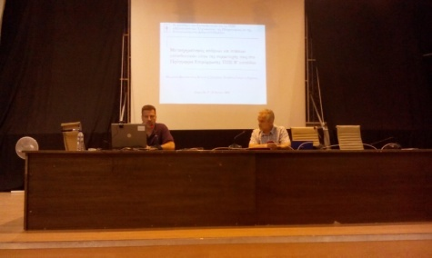 | https://www.scribd.com/doc/270146874/Presentation-in-SYROS-Conference-SIFA-Erasmus-pdf  http://www.authorstream.com/Presentation/hlapanis-2538020-presentation-syros-conference-sifa-erasmus/  http://youtu.be/2PlSsXniCfo

A3 Greece | 25 November 2015 | 1st Primary School of Kos  Students visit the primary school and talk with other students about internet safety, show videos, presentations, etc.  photos:  https://goo.gl/photos/EJ2c8WjHABkF575w6 | Presentation of video created by students  https://youtu.be/3qZiSiSlLEE  http://www.sifaplus.eu/en/ethics/gallery/item/339-video-about-safe-internet-for-all-meeting-in-greece-about-ethics  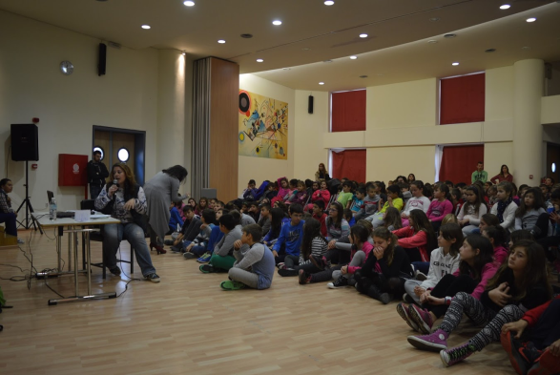
A3 Greece | 1 December 2015 | 1st High School of Kos  Students visit the primary school and talk with other students about internet safety, show videos, presentations, etc.  activities:  https://drive.google.com/folderview?id=0B6i1EVWz6r7mNmZ5RlJlSHRmYTg&usp=sharing  photos:  https://goo.gl/photos/XBKY7GvhZtMjWJs98 | Presentation of video created by students  https://youtu.be/3qZiSiSlLEE  http://www.sifaplus.eu/en/ethics/gallery/item/339-video-about-safe-internet-for-all-meeting-in-greece-about-ethics  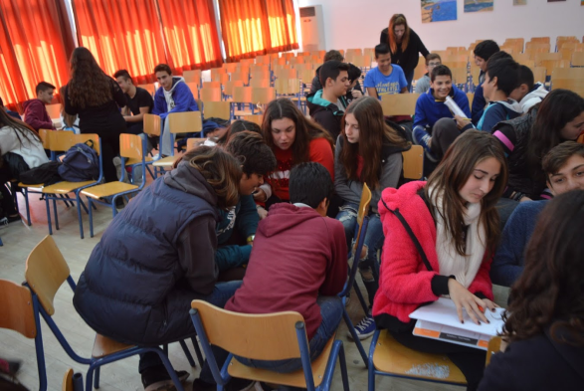
A3 Greece | 11 December 2015 | 1st High School of Kos  Students visit the primary school and talk with other students about internet safety, show videos, presentations, etc.  2nd visit within 10 days.  photos:  https://goo.gl/photos/bpbRPoJ61Xbau3eK6  activities:  https://drive.google.com/folderview?id=0B6i1EVWz6r7mNmZ5RlJlSHRmYTg&usp=sharing | Presentation of video created by students  https://youtu.be/3qZiSiSlLEE  http://www.sifaplus.eu/en/ethics/gallery/item/339-video-about-safe-internet-for-all-meeting-in-greece-about-ethics  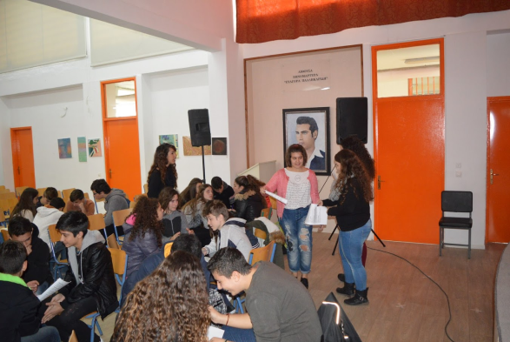

A5 All | October 2015 to  January 2016 | Further Teaching – Learning activities for Greece
A5 Greece | 25 November 2015 | 1st Primary School of Kos  Students visit the primary school and talk with other students about internet safety, show videos, presentations, etc.  photos:  https://goo.gl/photos/EJ2c8WjHABkF575w6  http://www.sifaplus.eu/en/ethics/results/item/343-dissemination-activities-students-teaching-other-students-in-greek-schools-1st-primary-school-of-kos | Presentation of video created by students  https://youtu.be/3qZiSiSlLEE  http://www.sifaplus.eu/en/ethics/gallery/item/339-video-about-safe-internet-for-all-meeting-in-greece-about-ethics
A5 Greece | 1 December 2015 | 1st High School of Kos  Students visit the primary school and talk with other students about internet safety, show videos, presentations, etc.  activities:  https://drive.google.com/folderview?id=0B6i1EVWz6r7mNmZ5RlJlSHRmYTg&usp=sharing  photos:  https://goo.gl/photos/XBKY7GvhZtMjWJs98 | Presentation of video created by students  https://youtu.be/3qZiSiSlLEE  http://www.sifaplus.eu/en/ethics/gallery/item/339-video-about-safe-internet-for-all-meeting-in-greece-about-ethics
A5 Greece | 11 December 2015 | 1st High School of Kos  Students visit the primary school and talk with other students about internet safety, show videos, presentations, etc.  2nd visit within 10 days.  photos:  https://goo.gl/photos/bpbRPoJ61Xbau3eK6  activities:  https://drive.google.com/folderview?id=0B6i1EVWz6r7mNmZ5RlJlSHRmYTg&usp=sharing | Presentation of video created by students  https://youtu.be/3qZiSiSlLEE  http://www.sifaplus.eu/en/ethics/gallery/item/339-video-about-safe-internet-for-all-meeting-in-greece-about-ethics
A5 Greece | October 2015 to November 2016 | Creation of report about the apps inventor product (during School Project by teacher Hlapanis G.) by students | http://www.sifaplus.eu/en/ethics/results/item/341-report-about-the-creation-of-the-apps-inventor-product
A5 Greece | October 2015 to November 2016 | Creation of report about the kahoot product (during School Project by teacher Hlapanis G.) by students | https://drive.google.com/file/d/0B6i1EVWz6r7mWFEwTlg2WmNGX3c/view?usp=sharing  http://www.sifaplus.eu/en/ethics/results/item/345-report-about-the-creation-of-the-kahoot-product
A5 Greece | October 2015 to January 2016 | Relative Project by teacher Koutsi | https://drive.google.com/folderview?id=0B6i1EVWz6r7mTHFQWURQMngyOXM&usp=sharing
A5 Greece | October 2015 to January 2016 | Relative Project by teacher Minaidi | https://drive.google.com/folderview?id=0B6i1EVWz6r7mTkRrRFJkU3JrcUk&usp=sharing  and  https://drive.google.com/folderview?id=0B6i1EVWz6r7mWENKcTlwM0NmMFE&usp=sharing
A5 Greece | October 2015 to November 2015 | Creation of video about the meeting in Greece and the learning activities (during School Project by teacher Hlapanis G.) | https://youtu.be/3qZiSiSlLEE  http://www.sifaplus.eu/en/ethics/gallery/item/339-video-about-safe-internet-for-all-meeting-in-greece-about-ethics
A5 Greece | October 2015 to January 2016 | Creation of video about the meeting in Greece and the learning activities (during School Project by teacher Hlapanis G.) | https://youtu.be/3qZiSiSlLEE  http://www.sifaplus.eu/en/ethics/gallery/item/340-video-about-safe-internet-for-all-meeting-in-greece-about-ethics-2nd
A5 Greece | November 2015 | Finalizing product for meeting in Greece (kahoot game) | http://www.sifaplus.eu/en/ethics/results/item/332-final-product-about-ethics-kahoot-game
A5 Greece | November 2015 | Finalizing product for meeting in Greece (apps inventor quiz/game) | http://www.sifaplus.eu/en/ethics/results/item/333-final-product-about-ethics-apps-inventor-quiz
A5 Greece | 6 December 2015 | SIFA DAY for parents at school. Parents were invited. Presentations by students and Phycologist Maria Drosou, movies and discussions took place. | https://drive.google.com/folderview?id=0B6i1EVWz6r7mVnhJeDhpSnhZbEU&usp=sharing
A5 Greece | 9 February 2016 | SIFA DAY for at school.  Webinar with other schools from Greece and Aris Louvris  http://vod-new.sch.gr/asset/detail/D1hPUkeNUuX6WZCMJPzpznr4/t1QepmUQNjmUVPmQkEL1f1ka##Top  and at the same time SIFA day at school for all students aged 15-17.  Presenting video Tagged and discussion activities.  A sample of the workshop and discussion:  https://youtu.be/wFyGlF2cC5w | http://www.etwinning.gr/various/webexreg.php?id=96  https://drive.google.com/folderview?id=0B8uze7tpG5WFZzM4X1JGNVdXcTg&usp=sharing  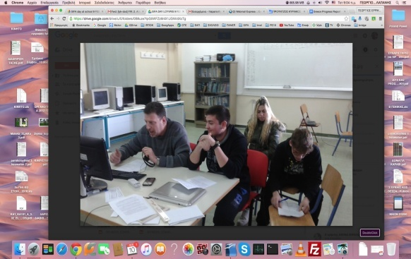  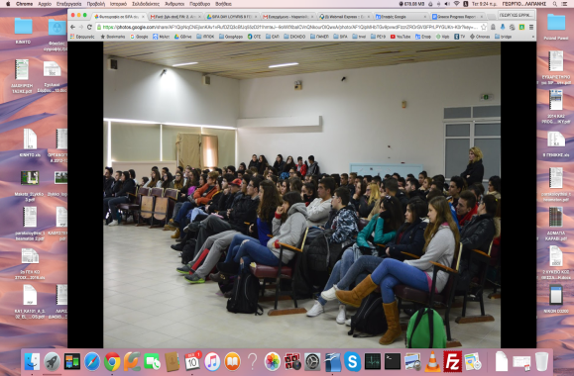  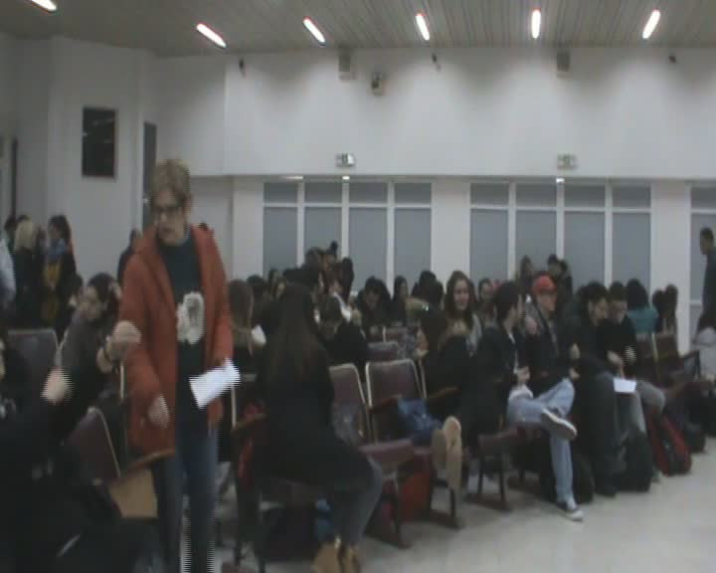
A5 Greece | 28 Feb 2015 | 2nd Lyceum of Kos with parents of students aged 15-18 from all schools of the region and teachers. Presentations, relevant videos and discussion. | Presentation by Drosou Maria https://youtu.be/uXR3TGSB-80  Presentation by Hlapanis Georgios  https://youtu.be/DHCpj_QkkxU
A5 Greece | 6/3/2015 | Relevant article on sifaplus.eu site. | http://www.sifaplus.eu/en/safety/articles/item/352-sifa-day-in-greece-and-preparation-activities
A5 Greece | 24/3/2016 | Webinar for informatics teachers of Greece, presenting SIFA, matters related to Internet Safety, Research Results.  http://blogs.sch.gr/webinarspe1920/2016/03/08/webinar2016004/ | https://docs.google.com/presentation/d/1FtqDqni4WZX_T7YsK-3E3V06SDcnrUr1yIiHo-myYxw/edit?usp=sharing  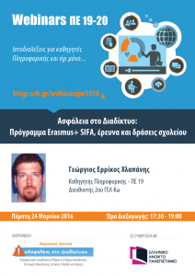
A5 Greece | 5/4/2016 | Visit to 7th Primary School of Kos - Presentation of SIFA and discussion about internet safety | Photos: https://goo.gl/photos/HbwARzkZN7XLjENm9  Presentation  https://drive.google.com/open?id=0B6i1EVWz6r7mTUhQeTZoM0gyWGM
A5 Greece | 11/4/2016 | Presentations at a seminar in Drama about SIFA, experience concerning internet Safety, Research results, etc.  https://goo.gl/photos/Xno2XEEPQZLJAFax7 | For parents:  https://docs.google.com/presentation/d/141M6XlrcAFRWo5071xKJbt4DTeaq4FMWeEYRPg6K2C4/edit?usp=sharing  And for teachers:  https://docs.google.com/presentation/d/1_FRQzXWHduYvy5WqAcuGmxUkIYEz4R8eBBNAwvxFMZE/edit?usp=sharing  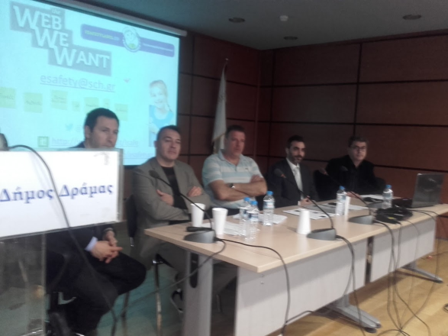

A5 All | April 2016 to  June 2016 | Further Teaching – Learning activities for Poland
A5 Greece | 9 May 2016 | Learning Activities,  Presentations, Exchanging experiences, Games (kahoot), Interviews and filling in of Questionnaires by many students of the school.  2 Kahoot games:  https://play.kahoot.it/#/?quizId=e8245355-039f-4fa4-811e-f759dde4135f  https://play.kahoot.it/#/?quizId=aa1a26fb-00f4-4c4e-9750-44b780239c79 | https://goo.gl/photos/zftZXZVVfAbm19cf6  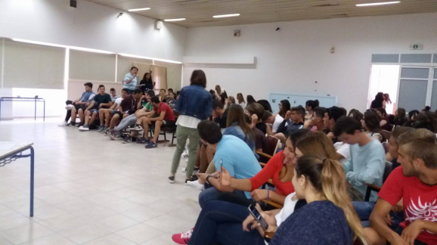

Poland

A3 Poland | 27 Dec 2015 | Forum on Internet addiction and visit in Austria – students who participated in the visit answered other students’ questions (on etwinning Twinspace) | http://www.sifaplus.eu/en/addictions/articles/item/53-forum-on-internet-addictions-and-visit-in-austria-etwinning-twinspace
A3 Poland | 29th Dec 2014 | A day without a mobile phone - students were asked not to use their mobile phones for 24 hours and write their comments as a follow-up. | http://www.sifaplus.eu/en/addictions?start=24
A3 Poland | 9th Jan 2015 | 'Virtual violence hurts in real life' - Polish students attend a lecture in LO Grojec given by ALTER organisation on cyberbullying and cyberstalking | http://www.sifaplus.eu/en/addictions/articles/item/65-virtual-violence-hurts-in-real-life-polish-students-attend-a-lecture
A3 Poland | Dec-Jan 2014 | Students who participated in the meeting give lectures to other classes and give a presentation on the first visit topic (internet addictions) to the whole school community. | Document signed by the Headteacher

A5 Poland | Dec – April 2014 | Conducting lessons for classes of LO Grojec: teacher to students and student to students. The lessons are part of the school curriculum and they concern the use of the Internet. | School digital register, list of lessons signed by the headteacher

A3 Poland | Feb-Apr 2015 | Presentation on Health and visit in Norway – students who participated in the visit answered other students’ questions while presenting information to classes at LO | Lesson subjects in the digital register – confirmed by the Headteacher
A3 Poland | April 2015 | Creating a film on the visit in Norway and later on displaying it as part of dissemination process. | http://www.sifaplus.eu/en/health/gallery/item/239-visit-in-norway-highlights
A3 Poland | 10th feb 2015 | Safe Internet Day: workshops organized by the High School of Information Technology in Warsaw followed by a test. | Certificates.  http://www.sifaplus.eu/en/health?start=12
A3 Poland | Feb-April 2015 | Students who participated in the meeting give lectures to other classes and give a presentation on the meeting topic to the whole school community. | School electronic register, confirmation from the Headteacher
A3 Poland | 26th March 2015 | Use the Internet in a safe way – workshops to middle school students from the local schools carried out by LO students | http://www.sifaplus.eu/en/health/articles/item/253-use-the-internet-in-a-safe-way

A5 Poland | February – June 2015 | Conducting lessons for classes of LO Grojec: teacher to students and student to students (health matters). The lessons are part of the school curriculum and they concern the use of the Internet. | School digital register, list of lessons signed by the headteacher

A4 Poland | Apr-May 2015 | Students and teachers who participated in the meeting give lectures to other classes and give a presentation on the visit topic (security) to the whole school community. | Pictures, document signed by headteacher, school register with subjects of lessons

A5 Poland | April – June 2015 | Conducting lessons for classes of LO Grojec: teacher to students and student to students. The lessons are part of the school curriculum and they concern the use of the Internet. | School digital register, list of lessons signed by the headteacher

A3 Poland | 5 Nov 2015 | Presentation on Ethics and visit in Greece – students who participated in the visit answered other students’ questions while presenting information to classes at LO | http://www.sifaplus.eu/en/ethics/articles/item/347-ethics-day-in-grojec
A3 Poland | October – January 2016 | Students who participated in the meeting give lectures to other classes and give a presentation on the meeting topic as well as the other project topics to the whole school community. | http://www.sifaplus.eu/en/ethics/articles/item/348-dissemination-presentations-given-by-polish-students

A3 Poland | October – January 2016 | Students teach other students about matters concerning safety on the Internet. | Class register.  http://www.sifaplus.eu/en/ethics/articles/item/348-dissemination-presentations-given-by-polish-students
A3 Poland | October 2015 | Organizing an IT course for students on copyrights and safety on the Internet | Students’ certificates.
A3 Poland | November 2015 | Organizing workshops on plagiarism and copyrights. | Class digital register.

A4 Poland | 5 Nov 2015 | SIFA Day at school – articles about the event appear on the school webite and in the local media | http://www.sifaplus.eu/en/ethics/articles/item/347-ethics-day-in-grojec
A4 Poland | Oct 2015 | Polish students’ memories after the visit in Greece – presenting the activities and reflections. | http://www.sifaplus.eu/en/ethics/articles/item/327-thank-you-from-poland

A5 Poland | Oct 2015 to  Jan 2016 | Conducting lessons for classes of LO Grojec: teacher to students and student to students. The lessons are part of the school curriculum and they concern the use of the Internet. | School digital register, list of lessons signed by the headteacher

A5 Poland | October 2015 | Organizing an IT course for students on copyrights and safety on the Internet | Students’ certificates.
A5 Poland | October – January 2016 | Students teach other students about matters concerning safety on the Internet. | Class register.  http://www.sifaplus.eu/en/ethics/articles/item/348-dissemination-presentations-given-by-polish-students
C9 C10 | 25.04.206 | Lecture and workshops at Jagiellonian University in Krakow | 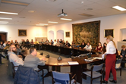
C9 C10 | 26.04.2016 | lecture and workshop run by FDN (Fundacja Dzieci Niczyje – organization cooperating with saferinternet.pl) (sexting and grooming) | 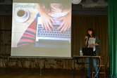
C9 C10 | 25-30.04.2016 | workshops / writing articles / work in groups - creating websites on weebly.com | http://sextingsifa.weebly.com  http://sifacyberbullying.weebly.com  http://offensivecontent.weebly.com  http://groomingandpredators.weebly.com/
C9 C10 | 27.04.2016 | lecture at Polish-Japanese University of Computer Technologies in Warsaw | 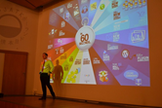
C9 C10 | 28.04.2016 | lecture (by ALTER) (on cyberbullying and cyberstalking) | 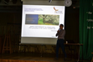
Licence Άδεια
Our SIFA project has officially ended. Yet, we relevant follow up activities will continue for at least two more years and especially dissemination activities for the results and products that have been created. We would like to thank all students, teachers, parents, organisations and scientists/guests that participated in some way and helped us during the project implementation.
The project is now under evaluation by the Greek National Agency and the products presented might be submitted to some change. Yet, meanwhile, we would like to present the Final Products of this 2 year collaboration, for which we are proud of and have been produced by all participants in SIFA. If they are submitted to changes, the current version will be updated by the revised versions.
Anybody can use the material produced during SIFA implementation, as long as they mention the Erasmus+ Project SIFA and that the products have been created by EU Erasmus+ funding.

The attachments (SIFA products) are licensed under a Creative Commons Attribution 4.0 International License and have been created during the implementation of the Erasmus+ Safe Internet For All (2014‐1‐EL01‐KA201‐001294) project.
Τα προϊόντα που ακολουθούν έχουν άδεια Creative Commons Αναφορά Δημιουργού - Παρόμοια Διανομή 4.0 Διεθνές και έχουν δημιουργηθεί στο πλαίσιο του προγράμματος Erasmus+ Safe Internet For All (Ασφαλές Διαδίκτυο για όλους - Σύμπραξη αποκλειστικά μεταξύ σχολείων με κωδικό 2014‐1‐EL01‐KA201‐001294)

